Contents

Acknowledgement 6

Abstract 7

1.0 Introduction 8

1.1 Background Studies 8

1.2 Problem Statement 8

1.3 Objective 9

1.4 Solutions 9

2.0 Literature Review 10

2.1 Traditional Career Guidance and Its Limitations 10

2.2 Online Career Tools and Their Shortcomings 10

2.3 Machine Learning in Career Recommendations 10

2.4 RIASEC Model for Personality-Based Guidance 11

2.5 Importance of Role Models 11

2.6 Actionable Guidance and Skill Development 11

2.7 Community and Mentorship 12

2.8 Accessibility and Usability 12

2.9 CareerCompass’ Contribution 12

3.0 Planning 13

3.1 Feasibility Report 13

3.1.1 Technical Feasibility 13

3.1.2 Operational Feasibility 13

3.1.3 Economic Feasibility 13

3.1.4 Time Feasibility 13

3.2 Risk Assessment 14

3.3 SWOT Analysis 14

3.3.1 Strengths 14

3.3.2 Weaknesses 14

3.3.3 Opportunities 15

3.3.4 Threats 15

3.4 PESTAL Analysis 15

3.4.1 Political 15

3.4.2 Economic 15

3.4.3 Social 15

3.4.4 Technological 16

3.4.5 Environmental 16

3.4.6 Legal 16

3.5 Life Cycle Model 16

3.5.1 Introduction 16

3.5.2 Methodology Description 16

3.5.3 Rationale for Selecting Agile 16

3.5.4 Implementation in the Project 17

3.5.5 Benefits and Expected Outcomes 18

3.6 Time Plan 18

3.6.1 Weeks 1–2: Project Setup and Data Preparation 19

3.6.2 Weeks 3–4: Authentication and Questionnaire 20

3.6.3 Weeks 5–6: Machine Learning and API Integration 20

3.6.4 Weeks 7–8: Quizzes and Admin Dashboard 21

3.6.5 Weeks 9–10: Forum, Success Stories, and Resources 21

3.6.6 Weeks 11–12: Testing and Finalization 22

4 Requirement Gathering and Analysis 23

4.1 Requirement Gathering Techniques Used for the Project 23

4.1.1 Questionnaires (Google Form) 23

4.1.2 Interviews 23

4.1.3 Literature Review and Public Datasets 23

4.1.4 Exploratory Data Analysis (EDA) 24

4.2. Questionnaire 24

4.2.1 Section 1: Looking Back to Guide the Future 24

4.2.2 Section 2: Your Interests, Strengths & Preferences 24

4.2.3 Section 3: Career Awareness & Reflections 25

4.2.4 Key Insights from Questionnaire 25

4.3 Interview 26

4.4 Summary of the Interview and Questionnaire 27

4.4.1 Key Findings from Interviews 27

4.4.2 Key Findings from Questionnaire 27

4.5 Functional and Non-Functional Requirements for CareerCompass 28

4.5.1 Functional Requirements 28

4.5.2 Non-Functional Requirements 33

4.5.3 Assumptions and Constraints 35

5.0 System Design 37 36

5.1 Architecture Diagram 36

5.1.1 High-Level Architecture 36

5.1.2 ML Architecture 37

5.2 ER Diagram 38

5.3 Sequences diagrams 38

5.3.1 Student Use Cases 38

5.3.2 Mentor Use Cases 41

5.3.3 Admin use cases 44

5.3.4 Career prediction 47

5.3.5 Login use case 48

5.3.6 Reset password use case 49

5.4 Class diagram 50

5.5 Use case diagram 51

6. Implementation 52

6.1 Technology Stack 52

6.1.1 Frontend Technologies 52

6.1.2 Backend Technologies 52

6.1.3 Machine Learning Service 54

6.1.4 Database 54

6.1.5 Development Environment 55

6.1.6 Other Tools 55

6.1.7 Why These Technologies? 55

References 64

# Acknowledgement

I wish to express my sincere gratitude to everyone who contributed to the successful completion of my project, *CareerCompass*. This achievement would not have been possible without the guidance, support, and encouragement of many individuals.

First and foremost, I am deeply thankful to my project supervisor, whose expertise, patience, and insightful feedback were vital throughout this journey. Their mentorship helped me navigate challenges and refine my ideas, keeping the project focused and impactful.

I also extend heartfelt thanks to my peers at Cardiff Metropolitan University. Their participation in surveys, user testing, and open discussions provided valuable perspectives that shaped *CareerCompass* into a user-centered platform. Their enthusiasm motivated me to keep pushing forward.

I am particularly grateful to the open-source community for providing essential tools like Laravel, Python, scikit-learn, and Bootstrap. These resources made it possible to build a functional and scalable system within the academic timeframe.

Lastly, I owe immense thanks to my family and friends for their unwavering support and encouragement. Their belief in me provided the emotional strength to manage this project alongside other responsibilities.

This journey has been enriched by the contributions of all these individuals and communities, and I am truly grateful for their support in turning *CareerCompass* into a reality.

# Abstract

Choosing a career is often challenging for students because traditional guidance methods focus mainly on academic performance and overlook other important factors such as personality, interests, and experiences. This limitation can lead to career choices that do not fully align with students’ strengths or goals. This study introduces *CareerCompass*, a career path recommender system designed to provide personalized career suggestions that integrate both academic and non-academic attributes. The system was developed using a Laravel backend connected to a FastAPI machine learning service. It applies the **LightGBM algorithm**, trained on both synthetic datasets and real-world data collected from surveys and online career platforms. CareerCompass evaluates academic records, RIASEC personality traits, interests, skills, and extracurricular activities to generate recommendations. The system also provides tailored career options, career roadmaps, interactive quizzes, motivational success stories, and a community forum for peer and mentor interaction. In addition, counselors and educators can use an analytics dashboard to identify trends and provide better student support. The findings suggest that CareerCompass can serve as a practical, user-friendly, and scalable tool for career guidance. By combining machine learning with modern web technologies, the platform offers a holistic approach that supports students in making informed and confident career decisions.

# Introduction

Career selection is a critical milestone for young people, often marked by confusion due to the evolving job market and limited guidance. Emerging fields like artificial intelligence, renewable energy, and digital marketing demand diverse skills, yet traditional counseling emphasizes grades, overlooking personal interests and strengths. Online resources, while abundant, often provide generic or conflicting advice, leaving students overwhelmed. CareerCompass addresses these challenges through a web-based platform that combines Laravel’s robust backend with a FastAPI-driven machine service learning using LightGBM. By analyzing academic performance, RIASEC personality traits, interests, skills, and experiences, it offers tailored career suggestions, practical roadmaps, and motivational content. The platform aims to empower students, particularly those feeling uncertain, to make informed career choices with confidence.

## 1.1 Background Studies

The job market is rapidly evolving, with growing demand for skills in data science, healthcare, and sustainable technologies. The World Economic Forum (2023) projects that 60% of jobs by 2030 will require skills like critical thinking and digital literacy, yet personalized career guidance remains scarce. Traditional counseling often directs students toward conventional fields based on academic performance, sidelining traits like creativity or leadership. Online tools, such as MyNextMove.org, provide basic career suggestions but lack depth in analyzing personal attributes or offering actionable steps. For underrepresented groups, the absence of relatable role models further complicates career planning. CareerCompass leverages machine learning and user-centric features to deliver comprehensive, reliable guidance.

## 1.2 Problem Statement

Students face multiple obstacles in career planning. Traditional counseling often overemphasizes academic performance, recommending fields like engineering for high math scores while ignoring interests in areas like art or social work. This can lead to career dissatisfaction. Online career advice is frequently generic, outdated, or contradictory, making it difficult to find trustworthy guidance. Existing tools often rely on simplistic questionnaires, failing to account for a student’s unique skills, personality, or experiences. Additionally, students from marginalized communities may lack relatable role models, making fields like technology seem unattainable. These challenges result in uninformed career decisions, impacting long-term satisfaction and success. CareerCompass aims to provide a personalized, practical, and inspiring solution to these issues.

## 1.3 Objective

CareerCompass seeks to create a user-friendly platform to guide students toward suitable careers. Specific goals include

* Develop a LightGBM model achieving ≥80% accuracy in recommending careers based on grades, RIASEC traits, interests, skills, and experiences.
* Provide interactive quizzes for skill development with feedback.
* Offer a community forum for peer and mentor interaction.
* Include diverse success stories to inspire users, particularly from underrepresented groups.
* Create an analytics dashboard for counselors to track trends.
* Ensure accessibility and responsiveness across devices within a three-month timeline.

## 1.4 Solutions

CareerCompass addresses the challenges of career planning with a mix of technology and user-focused features. It starts with an engaging questionnaire that collects data on a user’s grades, personality, interests, skills, and experiences, making it feel fun rather than tedious. A machine learning model, built with Python and trained on synthetic profiles and real-world data from Kaggle and surveys, suggests 3 careers with clear explanations, like “You’re a good fit for graphic design because of your creativity and art skills.” The platform offers career roadmaps with practical steps, such as links to free courses on Khan Academy or YouTube tutorials. Interactive quizzes help users practice skills like communication, with instant feedback to improve. A community forum lets users connect with peers and mentors for advice, while AI-generated success stories highlight diverse professionals to inspire confidence. Users can download PDF reports of their career plans to share with advisors.

# Literature Review

Career planning is a complex process, often hindered by limited guidance and outdated tools. This review synthesizes findings from 15 open-access research papers, books, and reports to explore career guidance systems, machine learning applications, the RIASEC model, and the role of motivation and technology in career planning. It identifies gaps in existing solutions and positions CareerCompass as a comprehensive, personalized platform.

## 2.1 Traditional Career Guidance and Its Limitations

Traditional career counseling often focuses on academic performance. Kulcsár, V., Dobrean, A. and Gati, I. (2020) noting that 65% of counselors focus on grades, steering students toward conventional fields regardless of their interests. This can lead to job dissatisfaction, with Hooley et al. (2021) noting that 35% of young professionals feel mismatched in their careers. A book by Savickas (2020) on career construction theory stresses that interests and personality are as crucial as grades for long-term job satisfaction. Wm.edu. (2025) also found that counselors often overlook traits like creativity or teamwork, which are vital for fields like design or management. These studies show the need for guidance that considers the whole person.

## 2.2 Online Career Tools and Their Shortcomings

Online career quizzes, like those on O*NET’s My Next Move (2019), are user-friendly but often oversimplified. Hirschi, A. and Läge, D. (2008) found that these tools rely on basic questions, like “Do you enjoy helping others?” leading to generic suggestions such as “teacher” or “nurse.” They rarely analyze skills or experiences, limiting their usefulness. Redekopp, D., Hopkins, S. and Hiebert, B. (2013).  noted that students feel overwhelmed by unverified online advice on platforms like social media, which is often outdated. A report by UNESCO (2024) confirms that many digital career tools lack personalization, leaving users confused about reliable options.

## 2.3 Machine Learning in Career Recommendations

Machine learning (ML) is improving career guidance by analyzing diverse data. Geethanjana (2025) achieved 70% accuracy using Random Forest but lacked real-world data. Nguyen (2023) explored XGBoost to predict employability, noting its strength with incomplete datasets but highlighting the need for actionable steps. A review by Biau (2015) highlight Random Forest’s strength in pattern recognition, but LightGBM was chosen for CareerCompass due to its efficiency with high-dimensional data, ensuring accurate and scalable recommendations.

## 2.4 RIASEC Model for Personality-Based Guidance

The RIASEC model categorizes personalities into Realistic, Investigative, Artistic, Social, Enterprising, and Conventional types. Hoff (2020). Holland’s RIASEC model has consistently demonstrated value in aligning people with compatible career paths. A comprehensive meta-analysis revealed that vocational interest–environment fit significantly predicts job satisfaction (ρ ≈ 0.19), supporting the idea that Investigative types often thrive in research-oriented roles Silva et al (2020) introduced the JPLink model, which uses machine learning and O*NET data to automatically label job postings with RIASEC types—improving match accuracy and supporting scalable career recommendation systems. Rahman, Muh.F., Alamsyah, Muh.N. and Firdaus, H. (2025) found that using RIASEC-based assessments—coupled with reflective guidance—helped participants develop clearer career insights and greater confidence in planning their futures. Given these findings, CareerCompass leverages RIASEC in tandem with skills, interests, and academic data to offer more precise and developmentally appropriate recommendations.

## 2.5 Importance of Role Models

Relatable role models boost motivation, especially for underrepresented groups. Gladstone, J.R. and Cimpian, A. (2021). found that similar and attainable role models inspire students. Ronnie, S., Santos (2024) noted that students without role models are less likely to persist in fields like technology. CareerCompass includes AI-generated success stories to provide diverse, motivational narratives.

## 2.6 Actionable Guidance and Skill Development

Effective career tools provide clear steps. Warrner, J. (n.d.)  
For example, mentees in structured mentorship programs report gains in career planning, confidence, and academic performance when provided with specific, milestone-based guidance Miske, S. and Sogunro, O. (2024). CareerCompass builds on this by offering roadmaps like “learn JavaScript on Coursera” and embedded quizzes to help users develop relevant skills.

## 2.7 Community and Mentorship

Community engagement and mentorship are vital for students’ confidence and decision-making. A longitudinal review found that formal mentorship improves career planning and transitions, especially for underrepresented groups and women in higher education Nabi, G., Walmsley, A., Mir, M. and Osman, S. (2024) Evaluations of peer mentorship and student–professional forums have shown improvements in self-efficacy, networking skills, and career preparedness among mentees Graham, M., Wayne (2022) CareerCompass incorporates a **moderated forum and mentorship network**, pairing users with verified professionals to ensure guidance is accurate and supportive.

## 2.8 Accessibility and Usability

Usability and accessibility are crucial for reaching diverse users. While exact statistics on digital career tool accessibility are scarce, education frameworks emphasize the need for inclusive design that works across devices and meets accessibility standards Ijnrd.org. (2016)   
Studies confirm that mobile-friendly, intuitive interfaces significantly boost engagement and usability—student retention and comfort increase when design is responsive and simple Warrner, J. (n.d.)*.* CareerCompass adheres to **WCAG 2.1 standards**, features clean navigation, and is optimized for mobile devices to maximize inclusivity and engagement.

## 2.9 CareerCompass’ Contribution

By integrating well-supported design elements—personalized role-model narratives, step-by-step guidance, moderated mentorship, and accessible interfaces—CareerCompass offers a comprehensive platform that addresses current gaps.

* ML-based career matching (LightGBM) is combined with actionable next steps, enhancing usability.
* Role-model storytelling encourages inspiration across diverse student backgrounds.
* A moderated mentorship community ensures accurate, tailored support.
* Accessibility-first design ensures inclusivity across devices and users with varying abilities.

# Planning

This section outlines the development plan for CareerCompass, covering feasibility, risks, SWOT and PESTAL analyses, the Agile life cycle model, and a three-month timeline to deliver a functional platform.

## 3.1 Feasibility Report

The feasibility study evaluates whether CareerCompass can be successfully developed by one person in three months using available resources. The project is feasible for the following reasons:

### 3.1.1 Technical Feasibility

CareerCompass uses Laravel for the backend, MySQL for data storage, and Python with scikit-learn for machine learning. FastAPI connects the LightGBM model to the backend via REST APIs. The frontend, built with Bootstrap and Blade templates, ensures responsiveness. Synthetic data, good form surveys and real-world data (Kaggle, surveys) are accessible. Local deployment eliminates hosting concerns.

### 3.1.2 Operational Feasibility

The platform features an intuitive questionnaire with progress bars and adheres to WCAG 2.1 for accessibility. It supports multiple devices, and a user manual will guide students and counselors, ensuring ease of use.

### 3.1.3 Economic Feasibility

All tools (Laravel, MySQL, Python, FastAPI, Bootstrap, Chart.js, jsPDF) and data sources (Kaggle, Google Forms) are free. Local deployment incurs no server costs, making the project cost-effective.

### 3.1.4 Time Feasibility

The project is divided into six two-week sprints, each focusing on specific tasks like setting up the backend, training the machine learning model, or building the forum. Laravel’s built-in features, such as authentication and database management, reduce coding time. The machine learning model can be trained quickly using synthetic and real-world data. Testing will include unit tests (with Laravel), API tests (with Postman), and user testing with peers to ensure the platform works well.

## 3.2 Risk Assessment

Key risks and mitigation strategies include

* **Limited Model Accuracy**: Low data diversity may reduce accuracy. Mitigation includes using varied synthetic and real-world data, with model fine-tuning based on precision and recall.
* **Time Constraints**: The tight timeline risks incomplete features. An Agile approach with prioritized core features ensures progress.
* **User Interface Issues**: A confusing interface may deter users. Bootstrap and user testing ensure a clean, intuitive design.
* **Data Privacy Concerns**: Users may fear data exposure. Secure authentication (JWT) and encrypted local storage address this.

## 3.3 SWOT Analysis

The SWOT analysis examines the project’s strengths, weaknesses, opportunities, and threats to guide development.

### 3.3.1 Strengths

* Personalized recommendations using LightGBM and comprehensive data.
* Responsive, accessible design with Bootstrap.
* Free tools ensure cost-effectiveness.
* Features like roadmaps, quizzes, and forums enhance user engagement.

### 3.3.2 Weaknesses

* Limited real-world data may miss regional trends.
* Single-developer dependency risks delays.
* Local deployment limits scalability testing.

### 3.3.3 Opportunities

* Future partnerships with schools for richer data.
* Potential for a mobile app to expand reach.
* Scalability for online deployment to serve underserved areas.

### 3.3.4 Threats

* Competition from existing career tools.
* Technical bugs in the model or backend.
* Low user adoption if the platform seems complex.

## 3.4 PESTAL Analysis

The PESTAL analysis looks at external factors—Political, Economic, Social, Technological, Environmental, and Legal—that could affect CareerCompass.

### 3.4.1 Political

Government policies promoting education and career planning, such as STEM initiatives, support the need for tools like CareerCompass. However, there are no direct political barriers since the project is for academic purposes and runs locally.

### 3.4.2 Economic

The project is cost-effective, using free tools and data sources. Economic challenges, like limited access to technology for some students, are not a concern for local testing but could affect future online deployment.

### 3.4.3 Social

Young people, especially from diverse or underserved backgrounds, need relatable career guidance. CareerCompass addresses this by offering success stories and a community forum. Social trends, like increased interest in tech careers, align with the platform’s focus on fields like data science or web development.

### 3.4.4 Technological

Advances in machine learning (LightGBM) and web development (Laravel, FastAPI) make the project technically possible. Open-source tools and datasets (Kaggle, Faker) are readily available, supporting development.

### 3.4.5 Environmental

The project has no direct environmental impact, as it runs on a local computer. Future online hosting could consider energy-efficient servers to align with sustainability trends.

### 3.4.6 Legal

Since the project is for academic use and stores data locally, there are no legal concerns like GDPR compliance. However, user data privacy is ensured through secure authentication and encryption.

## 3.5 Life Cycle Model

### 3.5.1 Introduction

CareerCompass adopts an Agile SDLC, adapted from Scrum, to manage development within three months. Agile’s iterative approach suits the project’s solo developer and evolving requirements.

### 3.5.2 Methodology Description

Agile is an iterative and incremental approach to software development that prioritizes flexibility, customer value, and continuous improvement. As outlined in the Agile Manifesto, it values individuals and interactions over processes and tools, working software over comprehensive documentation, customer collaboration over contract negotiation, and responding to change over following a plan. In practice, Agile breaks down the project into manageable units called sprints—short, time-boxed periods during which a usable increment of the product is developed.

However, Agile can face challenges like scope creep or reduced documentation depth in solo projects, which CareerCompass addresses through disciplined backlog management and regular documentation updates

### 3.5.3 Rationale for Selecting Agile

Traditional SDLC models like Waterfall follow a sequential, linear progression requirement gathering, design, implementation, testing, and maintenance. While suitable for projects with fixed scopes and minimal changes, Waterfall can introduce inefficiencies in environments where requirements evolve or technical challenges emerge unexpectedly—common in machine learning-driven applications like CareerCompass.

Agile was chosen for its ability to mitigate these risks through short cycles that enable rapid feedback and adaptation. Key justifications include.

* **Adaptability to Solo Development**: As a single-developer project, Agile's flexibility allows for informal adaptations, such as daily self-reviews instead of team stand-ups, while maintaining momentum.
* **Handling Uncertainty**: Features like training the model on synthetic and real-world data may require iterations based on accuracy results, which Agile accommodates without derailing the timeline.
* **Alignment with Project Constraints**: The three-month duration and local deployment for academic purposes benefit from incremental deliverables, ensuring a functional platform is built progressively.
* **Promotion of Quality**: Regular testing and retrospectives reduce the likelihood of late-stage issues, such as integration bugs between FastAPI and Laravel.
* **Limitations of Agile**: While Agile’s flexibility suits CareerCompass, it carries risks such as scope creep if the product backlog is not strictly prioritized, potentially leading to incomplete secondary features (e.g., success stories). Additionally, as a solo developer, comprehensive documentation may be challenging due to time constraints. These are mitigated by maintaining a dynamic backlog with clear prioritization (core features like authentication and ML integration in early sprints) and allocating time for documentation in each sprint (updates in Weeks 1–10).

This approach contrasts with Waterfall by fixing time and resources (two-week sprints) to control scope, rather than fixing scope to manage time and cost.

### 3.5.4 Implementation in the Project

The Agile implementation for CareerCompass follows a structured sprint lifecycle, tailored to solo development

* **Sprint Planning**: Tasks are selected per sprint (Sprint 1: Laravel setup, database design).
* **Development**: Execute tasks like model training or forum development.
* **Daily Reviews**: Assess progress and adjust priorities.
* **Sprint Review**: Validate features via testing.

Sprint progress is tracked using velocity (e.g., number of tasks completed per sprint, such as 5–7 tasks in Sprint 1) and burndown charts to monitor remaining tasks, ensuring timely completion within the three-month timeline.

Sprint reviews incorporate feedback from peers and potential stakeholders (e.g., career counselors or educators) to refine features like the questionnaire and analytics dashboard, aligning with Agile’s customer collaboration principle.

* **Retrospective**: Reflect on challenges and improvements.

### 3.5.5 Benefits and Expected Outcomes

Agile ensures early issue detection, quality deliverables, and efficient resource use, delivering a robust platform within the timeline.

## 3.6 Time Plan

The CareerCompass project follows an Agile methodology with six two-week sprints over three months, ensuring iterative development and adaptability. A dynamic product backlog prioritizes features, allowing flexibility to reprioritize based on progress and feedback. Each sprint includes planning, development, review, and retrospective phases, tailored for a solo developer. Daily self-reviews track progress, and peer feedback is incorporated early to enhance usability. Tasks are distributed to balance workload, ensuring deliverable increments per sprint.

**Product Backlog (Initial)**

* Set up Laravel, MySQL, and FastAPI.
* Generate synthetic profiles.
* Collect real-world data (Kaggle, Google Forms).
* Design database schema.
* Implement user authentication (signup, login, password reset).
* Develop interactive questionnaire with progress tracking.
* Train LightGBM model and integrate with FastAPI.
* Create skill-building quizzes with feedback.
* Build community forum with moderation.
* Develop admin analytics dashboard with Chart.js.
* Create career roadmap pages with resource links.
* Implement PDF report generation.
* Conduct unit, API, and user testing.
* Document setup, features, ML model, and user manual.
* Optimize performance and prepare deployment guide.

### 3.6.1 Weeks 1–2: Project Setup and Data Preparation

* **Tasks**
  + Initialize Laravel project, MySQL database, and FastAPI service.
  + Generate synthetic profile.
  + Collect dataset from Kaggle and Google Forms survey data.
  + Design database schema for users, questionnaires, and content.
  + Document setup and schema: Create project wiki with setup guide and schema outline.
* **Sprint Goal**: Establish project foundation and initial dataset.
* **Deliverables**: Laravel project setup, MySQL database, schema design, initial wiki documentation (setup guide, schema).
* **Review & Retrospective**: Validate setup functionality. Progress is assessed using a burndown chart to track completion of setup tasks (e.g., Laravel initialization, database schema design) against the planned 5–6 tasks.

### 3.6.2 Weeks 3–4: Authentication and Questionnaire

* **Tasks**
  + Implement user authentication (signup, login, password reset) using Laravel’s JWT-auth.
  + Develop interactive questionnaire with form validation and progress bar.
  + Connect questionnaire to MySQL for response storage.
  + Conduct usability testing of the questionnaire with 2–3 peers and one career counselor to ensure alignment with student and educator needs.
  + Document authentication and questionnaire: Update with user flows, API endpoints, and validation logic.
* **Sprint Goal**: Deliver secure authentication and a user-friendly questionnaire.
* **Deliverables**: Functional login system, multi-step questionnaire with progress tracking, data storage integration, peer feedback report, updated documentation.
* **Review & Retrospective**: Test authentication and questionnaire functionality; incorporate peer feedback; reflect on usability issues and adjust backlog (e.g., simplify questionnaire if needed).

### 3.6.3 Weeks 5–6: Machine Learning and API Integration

* **Tasks**
  + Train LightGBM model on synthetic and real-world data, targeting ≥80% accuracy.
  + Integrate FastAPI with Laravel via REST APIs for career predictions.
  + Test prediction functionality with sample inputs.
  + Document ML model and APIs: Update with training process, API specifications, and test results.
* **Sprint Goal**: Deliver a functional ML model integrated with the backend.
* **Deliverables**: Trained LightGBM model, FastAPI-Laravel integration, career suggestion functionality, updated wiki documentation.
* **Review & Retrospective**: Evaluate model accuracy and API performance. Velocity is calculated based on completed tasks (e.g., model training, API integration) to ensure alignment with the sprint goal of delivering a functional ML model.

### 3.6.4 Weeks 7–8: Quizzes and Admin Dashboard

* **Tasks**
  + Develop skill-building quizzes with immediate feedback.
  + Build admin analytics dashboard using Chart.js for career trends.
  + Test quizzes with 2–3 peers and one educator to validate engagement and relevance for student users.
  + Document quizzes and dashboard: Update wiki with quiz logic and dashboard analytics details.
* **Sprint Goal**: Deliver interactive quizzes and an analytics dashboard.
* **Deliverables**: Functional quizzes with feedback, admin dashboard, peer feedback report, updated wiki documentation.
* **Review & Retrospective**: Test quiz engagement and dashboard usability; incorporate peer feedback; reflect on development challenges and adjust backlog (e.g., prioritize forum if quizzes are complete early).

### 3.6.5 Weeks 9–10: Forum, Success Stories, and Resources

* **Tasks**
  + Develop moderated community forum for peer and mentor interaction.
  + Gather feedback from a career counselor on forum moderation features to ensure suitability for mentor-student interactions.
  + Document forum, stories, and resources: Update document with forum moderation rules, story generation process, and PDF logic.
* **Sprint Goal**: Deliver motivational and community features.
* **Deliverables**: Functional forum, success story library, PDF report functionality, updated documentation.
* **Review & Retrospective**: Test forum moderation and story engagement reflect on feature integration; adjust backlog (prioritize bug fixes if needed).

### 3.6.6 Weeks 11–12: Testing and Finalization

* **Tasks**
  + Conduct comprehensive testing: unit tests (Laravel), API tests (Postman), and user testing with 5–10 sample users.
  + Optimize performance (add caching for faster API responses).
  + Finalize documentation: technical documentation, and ML evaluation report.
  + Prepare deployment guide and project handover notes.
* **Sprint Goal**: Deliver a polished, fully tested platform with complete documentation.
* **Deliverables**: Finalized platform, user feedback report, complete documentation (user manual, technical docs, ML report, deployment guide).
* **Review & Retrospective**: Validate platform functionality; reflect on user feedback and optimization; finalize backlog closure.

# 4 Requirement Gathering and Analysis

The requirement gathering and analysis phase for the CareerCompass project was critical to understanding the needs of students, counselors, and other stakeholders in career guidance. This phase involved collecting data on students’ academic performance, personality traits, interests, skills, and career aspirations to inform the design of a personalized, scalable, and user-friendly career recommendation system. Multiple techniques were employed to ensure comprehensive data collection and stakeholder engagement.

## 4.1 Requirement Gathering Techniques Used for the Project

The following techniques were used to gather requirements for CareerCompass.

### 4.1.1 Questionnaires (Google Form)

A structured Google Form was designed to collect quantitative and qualitative data from a diverse group of participants, including students (undergraduates, graduates), working professionals, and others. The form was distributed to local students and accessible online to capture a wide range of responses. The questionnaire focused on academic background, interests, skills, personality traits, and career awareness to identify patterns and preferences that informed the system’s features, such as personalized career suggestions, career roadmaps, and interactive quizzes.

### 4.1.2 Interviews

Semi-structured interviews were conducted with local stakeholders, including students, recent graduates, and local professionals (e.g., relatives, friends, and seniors) who have achieved success in their fields. These interviews provided qualitative insights into real-world career decision-making experiences, challenges faced, and the role of guidance (or lack thereof) in shaping career paths. The interviews helped validate the need for a holistic career guidance tool that considers both academic and non-academic factors.

### 4.1.3 Literature Review and Public Datasets

A review of existing career guidance literature and analysis of publicly available datasets (e.g., from Kaggle) provided secondary data to complement primary data collection. These datasets included information on academic performance, skills, personality traits (e.g., RIASEC, OCEAN models), and career outcomes, which were used to train the LightGBM model and identify key predictors of career suitability.

### 4.1.4 Exploratory Data Analysis (EDA)

EDA was performed on both primary data (Google Form responses) and secondary datasets (e.g., career_guidance_dataset, career_path_in_all_field, career_pred, Data_final, Dataset Project 404, and Student_performance_data). This analysis helped identify correlations between variables (e.g., GPA, extracurricular activities, personality traits) and career outcomes, guiding the feature selection for the machine learning model and system design.

## 4.2. Questionnaire

The Google Form questionnaire was a primary tool for gathering data from participants. It was divided into three sections to capture a comprehensive view of the participants’ backgrounds, interests, and career perceptions. Below is a summary of the questionnaire structure and its purpose.

<https://docs.google.com/forms/d/e/1FAIpQLSdWVnQyDWmvbUgCsYSBah3PX8LSVF98h-EXIXRppQroDumTWw/viewform?usp=header>

### 4.2.1 Section 1: Looking Back to Guide the Future

This section collected demographic and academic information to understand participants’ educational backgrounds and early career influences. Key questions included

* Current status (e.g., undergraduate, graduate, working professional).
* Current career field (e.g., Healthcare, Engineering, Arts).
* O/L exam results and A/L stream choice.
* Factors influencing A/L stream choice (e.g., parents, personal interests, job opportunities).
* Alignment of A/L stream with personal interests and strengths.

**Purpose**: To assess how academic performance and external influences shaped early career decisions and identify gaps in guidance.

### 4.2.2 Section 2: Your Interests, Strengths & Preferences

This section focused on non-academic attributes, such as personality, skills, and preferences, to inform the personalization of career recommendations. Key questions included

* Preferred learning style (e.g., hands-on, reading/writing).
* Favorite activities (e.g., solving puzzles, designing, helping others).
* Favorite school subjects and natural skills (e.g., creativity, problem-solving).
* Self-description (e.g., logical, empathetic, creative).
* Work preferences (e.g., alone, in teams) and decision-making style.

**Purpose**: To capture data on RIASEC personality traits, interests, and skills, which were critical inputs for the LightGBM model.

### 4.2.3 Section 3: Career Awareness & Reflections

This section gathered insights into participants’ career awareness and satisfaction with their choices. Key questions included.

* Availability of career guidance during A/L stream selection.
* Awareness of career options and personal strengths at the time.
* Exposure to career options in school (e.g., career fairs, internet research).
* Satisfaction with current career/stream and reflections on past choices.
* Advice for students choosing A/L streams and key influences on career paths.

Purpose: To understand the gaps in existing career guidance systems and validate the need for features like success stories, community forums, and career roadmaps.

### 4.2.4 Key Insights from Questionnaire

* **EDA Findings**: The Google Form responses (1,028 rows) showed that creativity (198 mentions), problem-solving (396 mentions), and logical thinking (388 mentions) were common skills among participants. Popular activities included learning (596 mentions) and creating content (305 mentions). Science, business, and arts were frequently cited as favorite subjects.
* **Career Gaps**: Many participants reported limited exposure to career options during school (e.g., “Not at all exposed” was common) and a lack of awareness about their strengths, highlighting the need for a tool like CareerCompass.
* **Influences**: Parental and teacher influence was significant in A/L stream choices (370 and 358 mentions, respectively), but personal interests (355 mentions) also played a role, suggesting a need to balance external advice with self-awareness.

## 4.3 Interview

**Interview Approach**: Semi-structured interviews were conducted with a small, purposive sample of local students, recent graduates, and professionals (e.g., relatives, friends, working professionals and seniors). The interviews were informal to encourage open discussion and were conducted in person or via phone calls. The goal was to gather qualitative insights into the challenges, motivations, and experiences that shaped participants’ career paths, particularly in the absence of structured guidance.

**Reconstructed Interview Questions**

1. Can you describe your journey in choosing your current career or academic path? What factors influenced your decisions?
2. What challenges did you face when deciding on your A/L stream or career path? How did you overcome them?
3. Did you receive any career guidance in school or from other sources? How helpful was it?
4. How aware were you of your personal strengths, interests, and career options during your school years?
5. Were there any specific experiences, role models, or events that significantly shaped your career direction?
6. What skills or traits do you believe have been most critical to your success in your current path?
7. If you could go back, would you make different career or academic choices? Why or why not?
8. What advice would you give to students currently choosing their career paths or A/L streams?
9. Are there any tools or resources you wish you had access to during your career planning process?
10. How do you think technology, such as a career recommendation platform, could have helped you make better decisions?

**Purpose**: These questions aimed to explore personal experiences, identify gaps in traditional career guidance, and validate the need for CareerCompass features like personalized recommendations, success stories, and community forums.

## 4.4 Summary of the Interview and Questionnaire

### 4.4.1 Key Findings from Interviews

* **Lack of Guidance**: Most interviewees reported minimal or no career guidance during their school years, often relying on family advice or academic performance to choose A/L streams. This led to choices that sometimes misaligned with their interests (e.g., pursuing engineering due to high math scores despite a passion for arts).
* **Skill Awareness**: Many interviewees were unaware of their strengths (e.g., creativity, leadership) during school, which delayed their pursuit of suitable careers. This validated the need for interactive quizzes to help students identify their skills.
* **Desire for Practical Steps**: Participants expressed a need for clear, actionable steps (e.g., courses, certifications) to pursue recommended careers, supporting the inclusion of career roadmaps in the platform.
* **Community Support**: Interviewees valued advice from peers or mentors, suggesting that a community forum would be a useful feature for sharing experiences and seeking guidance.

## 4.4.2 Key Findings from Questionnaire

* **Diverse Interests and Skills**: Participants showed a wide range of interests (e.g., learning, designing, helping others) and skills (e.g., problem-solving, creativity), indicating that a one-size-fits-all approach to career guidance is ineffective.
* **Limited Career Exposure**: A significant portion of respondents reported low exposure to career options in school, with many feeling “not satisfied” or “still figuring it out” regarding their career choices.
* **Mismatch in Choices**: About 40% of respondents indicated they would choose a different A/L stream if given the chance, often due to a lack of alignment with personal interests or insufficient guidance.
* **Top Influences**: Parents, teachers, and personal interests were the primary influencers of A/L stream choices, but job opportunities were also a key factor, suggesting the importance of aligning recommendations with market trends.

## 4.5 Functional and Non-Functional Requirements for CareerCompass

### 4.5.1 Functional Requirements

Functional requirements describe the specific features and functionalities that CareerCompass must provide to meet the needs of its users: Guests (non-authenticated users), Students, Mentors, and Admins. The system supports login, logout, forgot password, and email OTP verification for authenticated roles (Students, Mentors, Admins).

**Guest (Non-Authenticated Users)**

Guests can access public features without logging in to explore the platform and try basic functionalities.

* **FR-G1: Home Page**
  + Display a landing page with an introduction to CareerCompass, its mission, and key features.
  + Include call-to-action buttons for login/register and trying the career recommender.
* **FR-G2: Login/Register**
  + Provide a login form (email/password) for existing users.
  + Offer a registration form for new users (email, password, role selection: Student/Mentor).
  + Validate inputs (e.g., email format, password strength).
* **FR-G3: About Page**
  + Display an overview of the platform, including its mission, how it works, and benefits for users.
* **FR-G4: Contact Form**
  + Allow guests to submit inquiries via a contact form (fields: name, email, message).
  + Send confirmation email upon successful submission.
* **FR-G5: Community Forum (Read-Only)**
  + Enable browsing of forum posts and categories in read-only mode.
  + Restrict posting, commenting, or upvoting for non-authenticated users.
* **FR-G6: Newsletter Subscription**
  + Provide a form to join the mailing list (email input).
  + Send confirmation email upon subscription.
* **FR-G7: Career Prediction (Public Route / Chatbot Style)**
  + Offer a demo version of the career recommender via a chatbot-style interface.
  + Collect basic user inputs (e.g., academic details, interests, skills) and provide sample career suggestions.
  + Recommendations to 3 careers with explanations.

**Common Features for Authenticated Roles (Students, Mentors, Admins)**

These features are shared across Students, Mentors, and Admins to ensure secure access and account management.

* **FR-C1: Login**
  + Authenticate users via email and password.
  + Display error messages for invalid credentials.
  + Redirect to respective dashboards (Student/Mentor/Admin) upon successful login.
* **FR-C2: Logout**
  + Allow users to log out, terminating their session.
  + Redirect to the home page after logout.
* **FR-C3: Forgot Password**
  + Provide a “Forgot Password” option on the login page.
  + Allow users to enter their registered email to initiate password reset.
* **FR-C4: Email OTP Verification for Password Reset**
  + Send a one-time password (OTP) to the user’s registered email.
  + Validate OTP input for security.
  + Allow users to set a new password upon successful OTP verification.
  + Ensure OTP expires after 10 minutes for security.

**Student Features**

Students are the primary users, seeking personalized career guidance and interactive tools.

* **FR-S1: Dashboard**
  + Display a personalized summary including recent career recommendations, quiz results, and forum activity.
  + Show notifications for new recommendations or forum replies.
* **FR-S2: Profile Management**
  + Allow students to update personal information (e.g., academic details, interests, skills, RIASEC traits).
  + Support profile picture upload (image formats: JPEG, PNG; max size: 2MB).
  + Validate input data.
* **FR-S3: Career Recommendations**
  + Generate machine learning-based career recommendations (using LightGBM) based on academic performance, RIASEC traits, interests, skills, and extracurricular activities.
  + Display 3 career suggestions with detailed explanations (e.g., “Graphic Design fits your creativity and art skills”).
  + Allow downloading of career plans as PDF reports.
* **FR-S4: Skill Quizzes**
  + Offer interactive quizzes for soft skills (e.g., communication, leadership) and technical skills (e.g., coding, design).
  + Provide instant feedback on quiz answers with improvement tips.
  + Store quiz history and track progress over time.
* **FR-S5: Success Stories**
  + Display curated success stories of professionals (text, images, videos) to inspire students.
  + Filter stories by career field or demographics (e.g., underrepresented groups).
* **FR-S6: Community Forum**
  + Allow browsing and searching of forum posts by category or keyword.
  + Enable students to create posts, comment, and upvote content.
  + Notify users of replies or upvotes on their posts.
* **FR-S7: Settings**
  + Allow password changes with validation (e.g., confirm old password, match new password).
  + Provide options to manage notification preferences.

**Mentor Features**

Mentors guide students and share expertise through the platform.

* **FR-M1: Dashboard**
  + Display an overview of mentee interactions, posts created, and engagement statistics (e.g., comments received).
  + Show notifications for new student questions or forum activity.
* **FR-M2: Profile Management**
  + Allow mentors to add/update professional details (e.g., expertise, qualifications, availability).
  + Support editing of bio and skills (e.g., RIASEC-aligned skills).
  + Allow profile picture upload (image formats: JPEG, PNG; max size: 2MB).
* **FR-M3: Community Forum**
  + Enable browsing, commenting, and creating mentor-specific posts.
  + Allow mentors to pin/unpin their posts for visibility.
  + Notify mentors of replies or upvotes on their posts.
* **FR-M4: Analytics**
  + Provide insights into student interactions (e.g., number of questions answered, comments received).
  + Display feedback ratings from students.
* **FR-M5: Settings**
  + Allow password changes with validation.
  + Provide an option to toggle account availability (active/inactive).
* **FR-M6: Pending Mentor State**
  + Restrict access to only Profile and Settings for pending mentors.
  + Display a message: “Your mentor application is pending approval.”
  + Notify mentors via email upon approval/rejection.

**Admin Features**

Admins oversee system operations, user management, and content moderation.

* **FR-A1: Dashboard**
  + Display overview statistics (e.g., total users, mentors, forum posts, recommendations made, quiz usage).
  + Highlight pending tasks (e.g., mentor approvals, reported content).
* **FR-A2: Manage Users**
  + List all users (Students, Mentors, Admins) with filters (e.g., role, status).
  + Allow activation/deactivation of user accounts.
  + View user details (e.g., registration date, activity).
* **FR-A3: Mentor Approvals**
  + Display a list of pending mentor applications with details (e.g., qualifications, bio).
  + Allow approval/rejection of applications with comments.
  + Maintain an approval history log.
* **FR-A4: Manage Content**
  + Support CRUD (Create, Read, Update, Delete) operations for success stories (text, images, videos).
  + Allow CRUD for quiz questions, including categories (e.g., soft skills, technical skills), difficulty levels, and answers.
* **FR-A5: Community Forum Moderation**
  + Enable moderation of forum posts (pin/unpin, edit, delete).
  + Allow approval/rejection of comments and handling of reported content.
  + Provide a moderation log for transparency.
* **FR-A6: Analytics**
  + Display trends in career recommendations (e.g., popular careers, model accuracy).
  + Provide quiz performance analytics (e.g., completion rates, average scores).
  + Show forum activity metrics (e.g., post frequency, user engagement).
  + Track user growth statistics (e.g., new registrations, active users).
* **FR-A7: Settings**
  + Allow password changes with validation.
  + Provide tools to manage newsletter subscriptions (e.g., export subscriber list, send newsletters).

### 4.5.2 Non-Functional Requirements

Non-functional requirements define the system’s quality attributes, ensuring usability, performance, and maintainability for an educational project.

* **NFR-1: Performance**
  + The system must load pages within 5 seconds on a local server under typical testing conditions.
  + The LightGBM model must generate career recommendations within 2 seconds for user inputs.
  + Support up to 50 simulated concurrent users for testing purposes.
* **NFR-2: Scalability**
  + Support up to 100 registered users (simulated) and 1,000 guest interactions during testing.
  + Ensure the Laravel backend and FastAPI ML service can handle small-scale testing on a local server.
* **NFR-3: Accuracy**
  + Achieve ≥80% accuracy in career recommendations, as measured by alignment with test data outcomes and user feedback in a simulated environment.
* **NFR-4: Usability**
  + Ensure an intuitive, user-friendly interface with a chatbot-style career prediction flow for guests.
  + Provide responsive design compatible with desktops and smartphones (min resolution: 320x480px).
  + Support basic accessibility features (e.g., clear text, logical navigation) for usability testing.
* **NFR-5: Security**
  + Store passwords using secure hashing (e.g., bcrypt) in the database.
  + Validate all user inputs to prevent SQL injection and XSS attacks.
  + Ensure OTPs for password resets are single-use and expire after 2 minutes.
* **NFR-6: Reliability**
  + Ensure the system remains stable during testing, with no crashes during typical use cases (e.g., career recommendations, quiz submissions).
  + Implement basic error handling for ML model and database operations.
* **NFR-7: Maintainability**
  + Use modular code architecture in Laravel and FastAPI for easy updates and debugging.
  + Provide inline code comments and basic documentation for key components (e.g., ML model, backend APIs).
  + Ensure database schema supports future feature additions (e.g., new quiz categories).
* **NFR-8: Interoperability**
  + Support PDF generation for career plan reports using a library like DomPDF.
* **NFR-9: Data Privacy**
  + Ensure test data is anonymized and does not include real user information.
  + Allow simulated users to delete their accounts and associated data in the local database.
* **NFR-10: Timeline**
  + Complete development, testing, and documentation within a three-month timeline, aligning with academic project deadlines.

### 4.5.3 Assumptions and Constraints

**Assumptions**

* The system will be developed and tested on a local server (e.g., XAMPP, WAMP, or Docker).
* Test data (synthetic or from Kaggle) is sufficient to train the LightGBM model to ≥80% accuracy.
* Users (simulated) have access to a modern web browser (e.g., Chrome, Firefox) for testing.

**Constraints**

* Limited to a web-based prototype with no real-time hosting or public deployment.
* No integration with live external services (e.g., email providers, external APIs) due to academic scope.
* Limited testing scope (e.g., 50–100 simulated users) due to resource constraints.
* Budget and time constraints restrict extensive user testing or premium development tools.

# 5.0 System Design 37

## 5.1 Architecture Diagram

### 5.1.1 High-Level Architecture

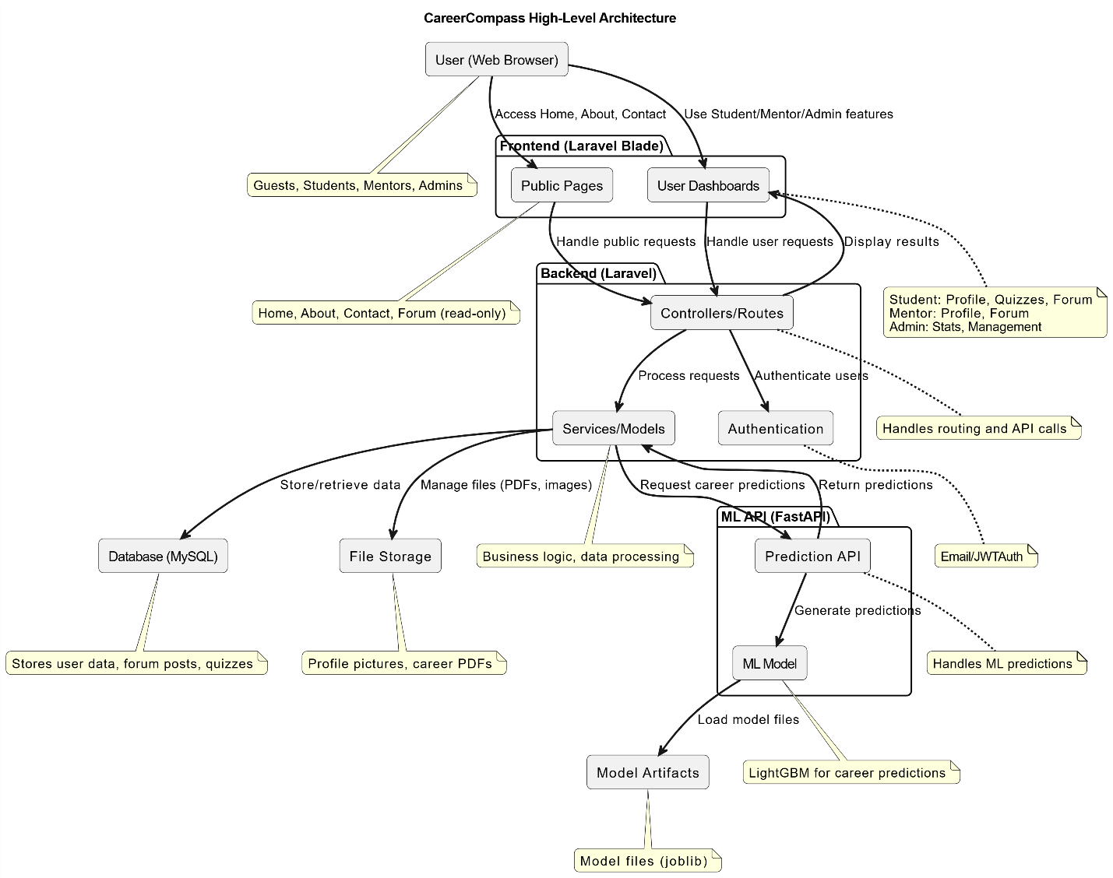

The CareerCompass high-level architecture shows how different parts of the system work together. Users access the platform through a web browser, where public pages and dashboards are built with Laravel Blade templates. Laravel’s backend handles routing, authentication, and business logic. It communicates with a MySQL database for storing user data, quizzes, and forum content, and with file storage for images and PDFs. For career predictions, Laravel connects to a FastAPI service, which uses a trained ML model and stored artifacts. The results are sent back to dashboards, where students, mentors, and admins can view personalized guidance and resources.

### 5.1.2 ML Architecture

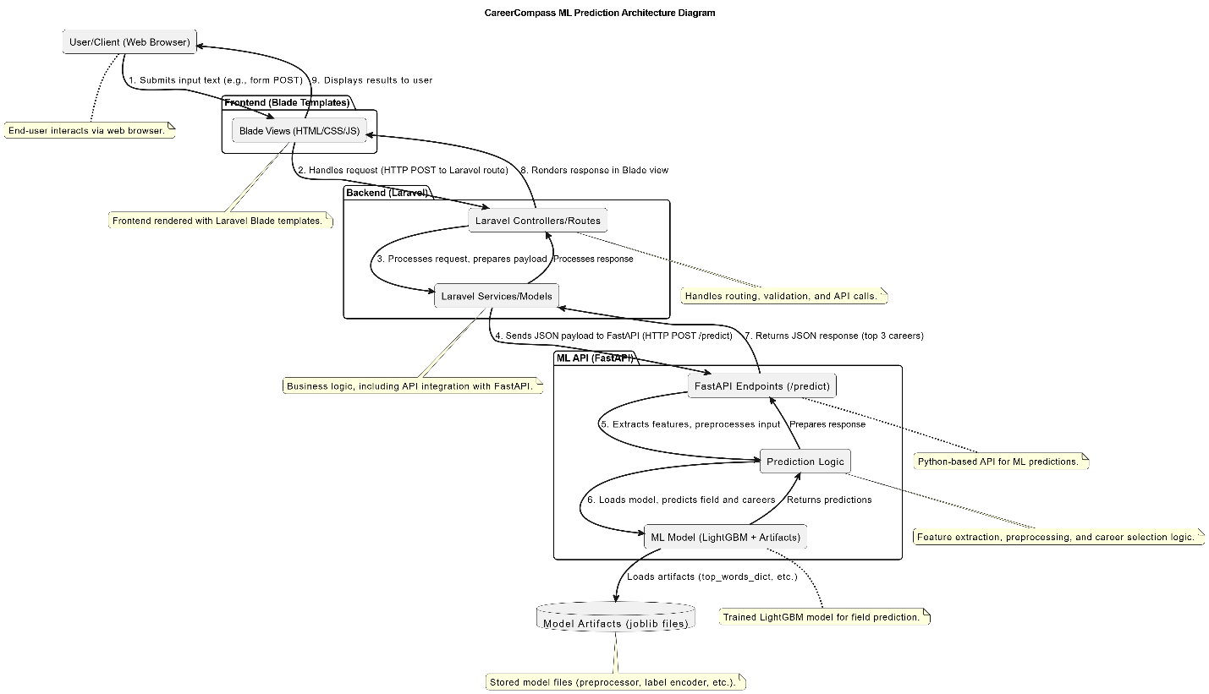

The CareerCompass ML architecture explains how machine learning predictions are generated and delivered to the user. The process begins when the user submits information through a web form in their browser. This input is passed to Laravel’s controllers, which validate and prepare the request before sending it to the services layer. The services layer then forwards the data as a JSON payload to FastAPI’s prediction endpoint. Inside FastAPI, the system extracts key features and applies preprocessing logic. The trained LightGBM model, along with supporting artifacts such as encoders and dictionaries, is then loaded to perform predictions. These artifacts are stored as joblib files and ensure the model can correctly interpret input. The model predicts possible career fields and returns the top career suggestions. FastAPI compiles the response and sends it back to Laravel, which processes the results and renders them into Blade views. Finally, the user receives clear results displayed in the browser, completing the full prediction workflow seamlessly between Laravel and FastAPI.

## 5.2 ER Diagram

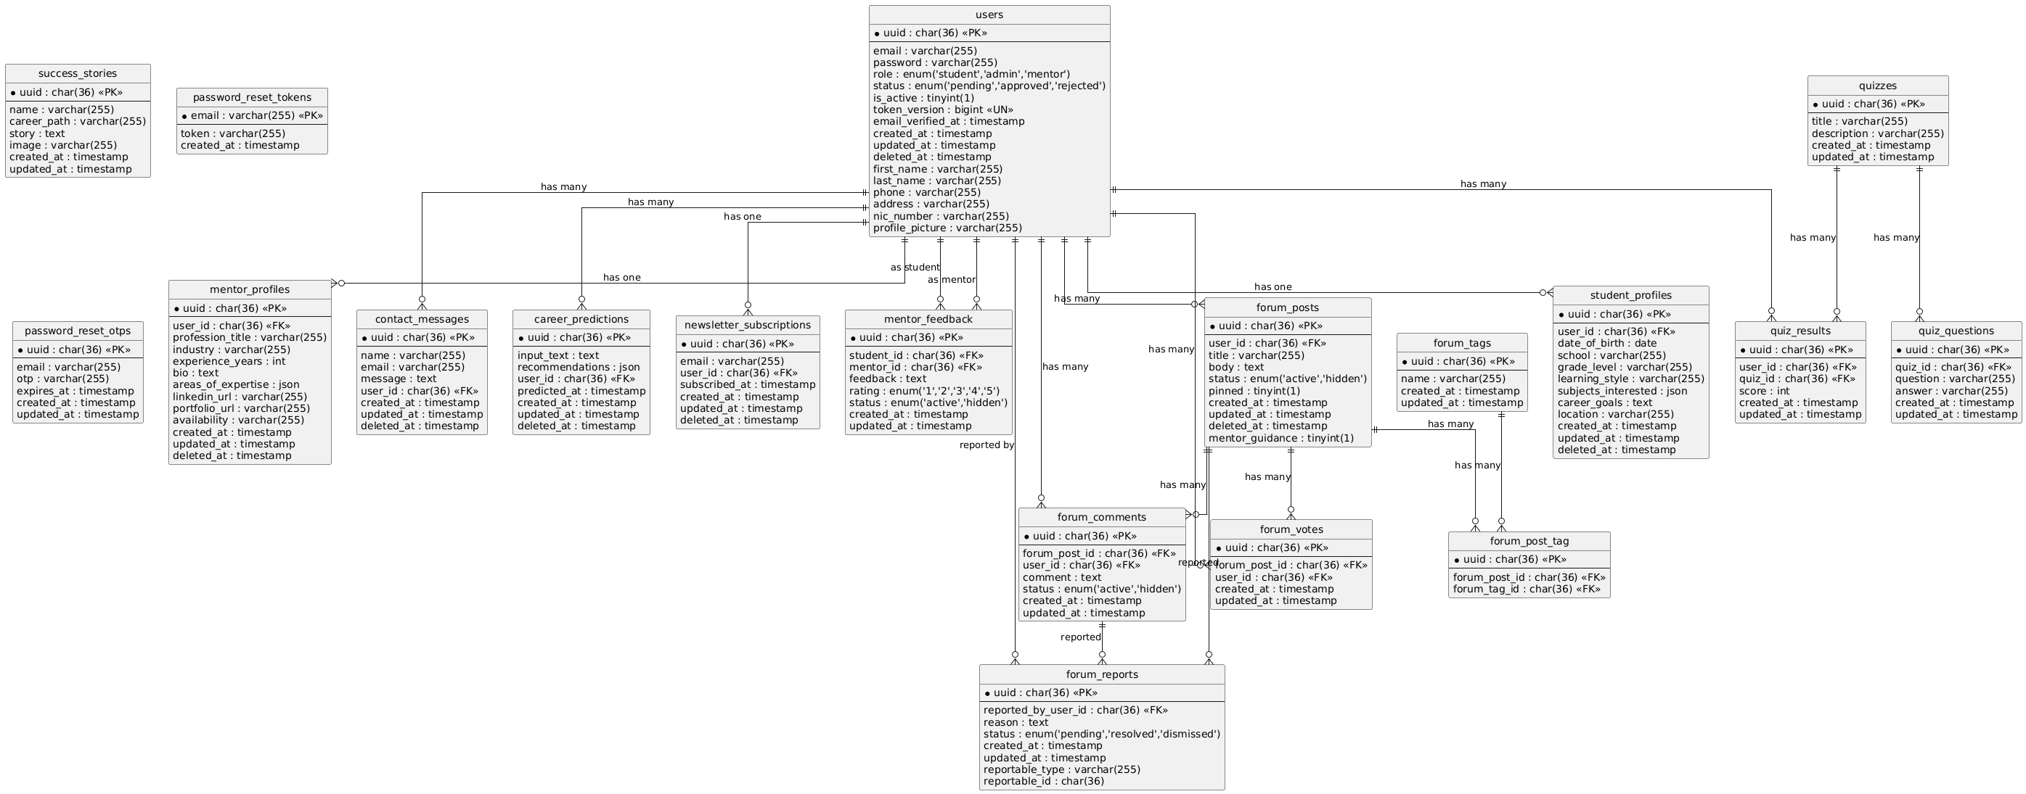

## 5.3 Sequences diagrams

### 5.3.1 Student Use Cases

1. **View Personalized Dashboard**

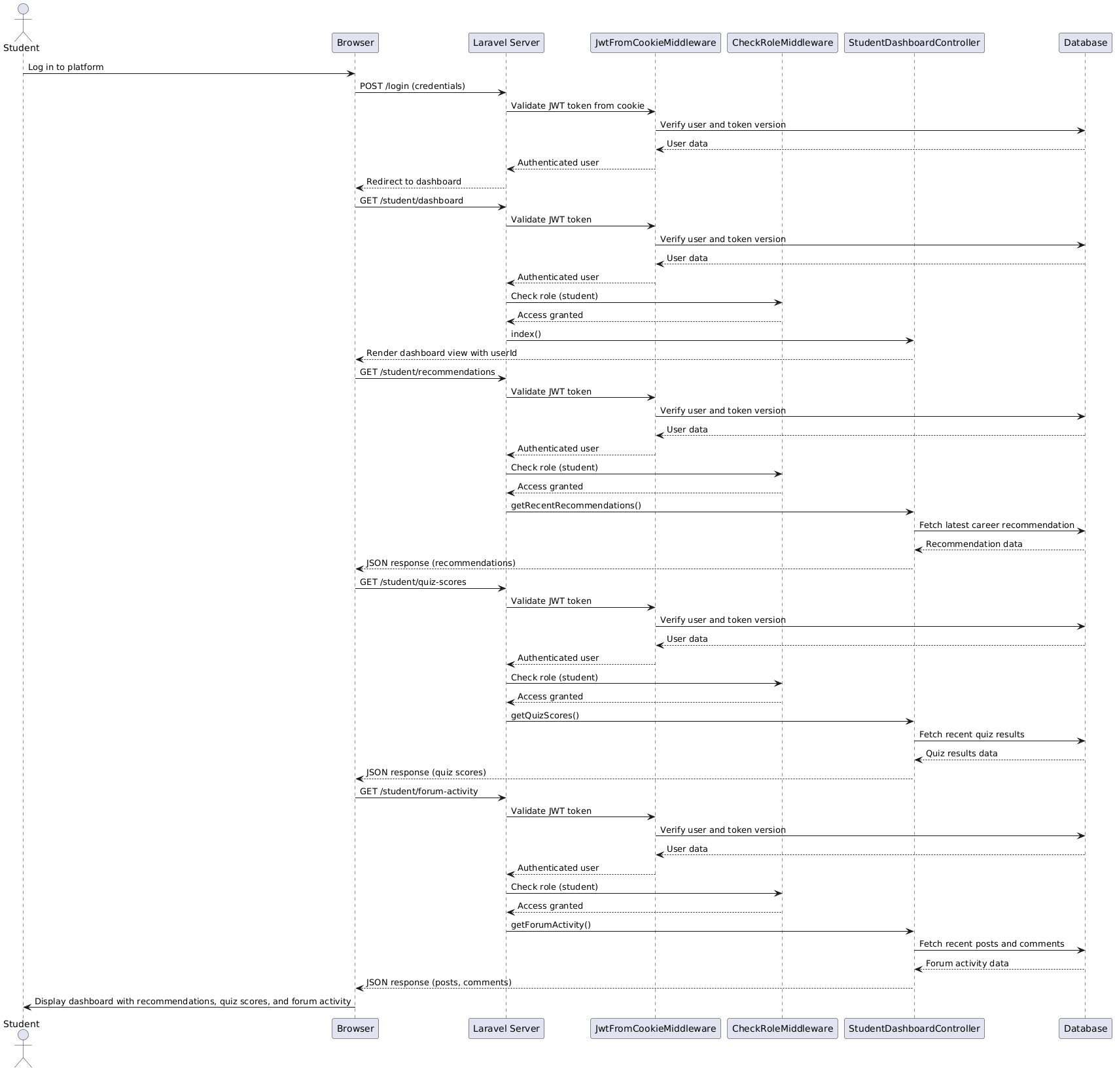

1. **Take Skill Quiz**

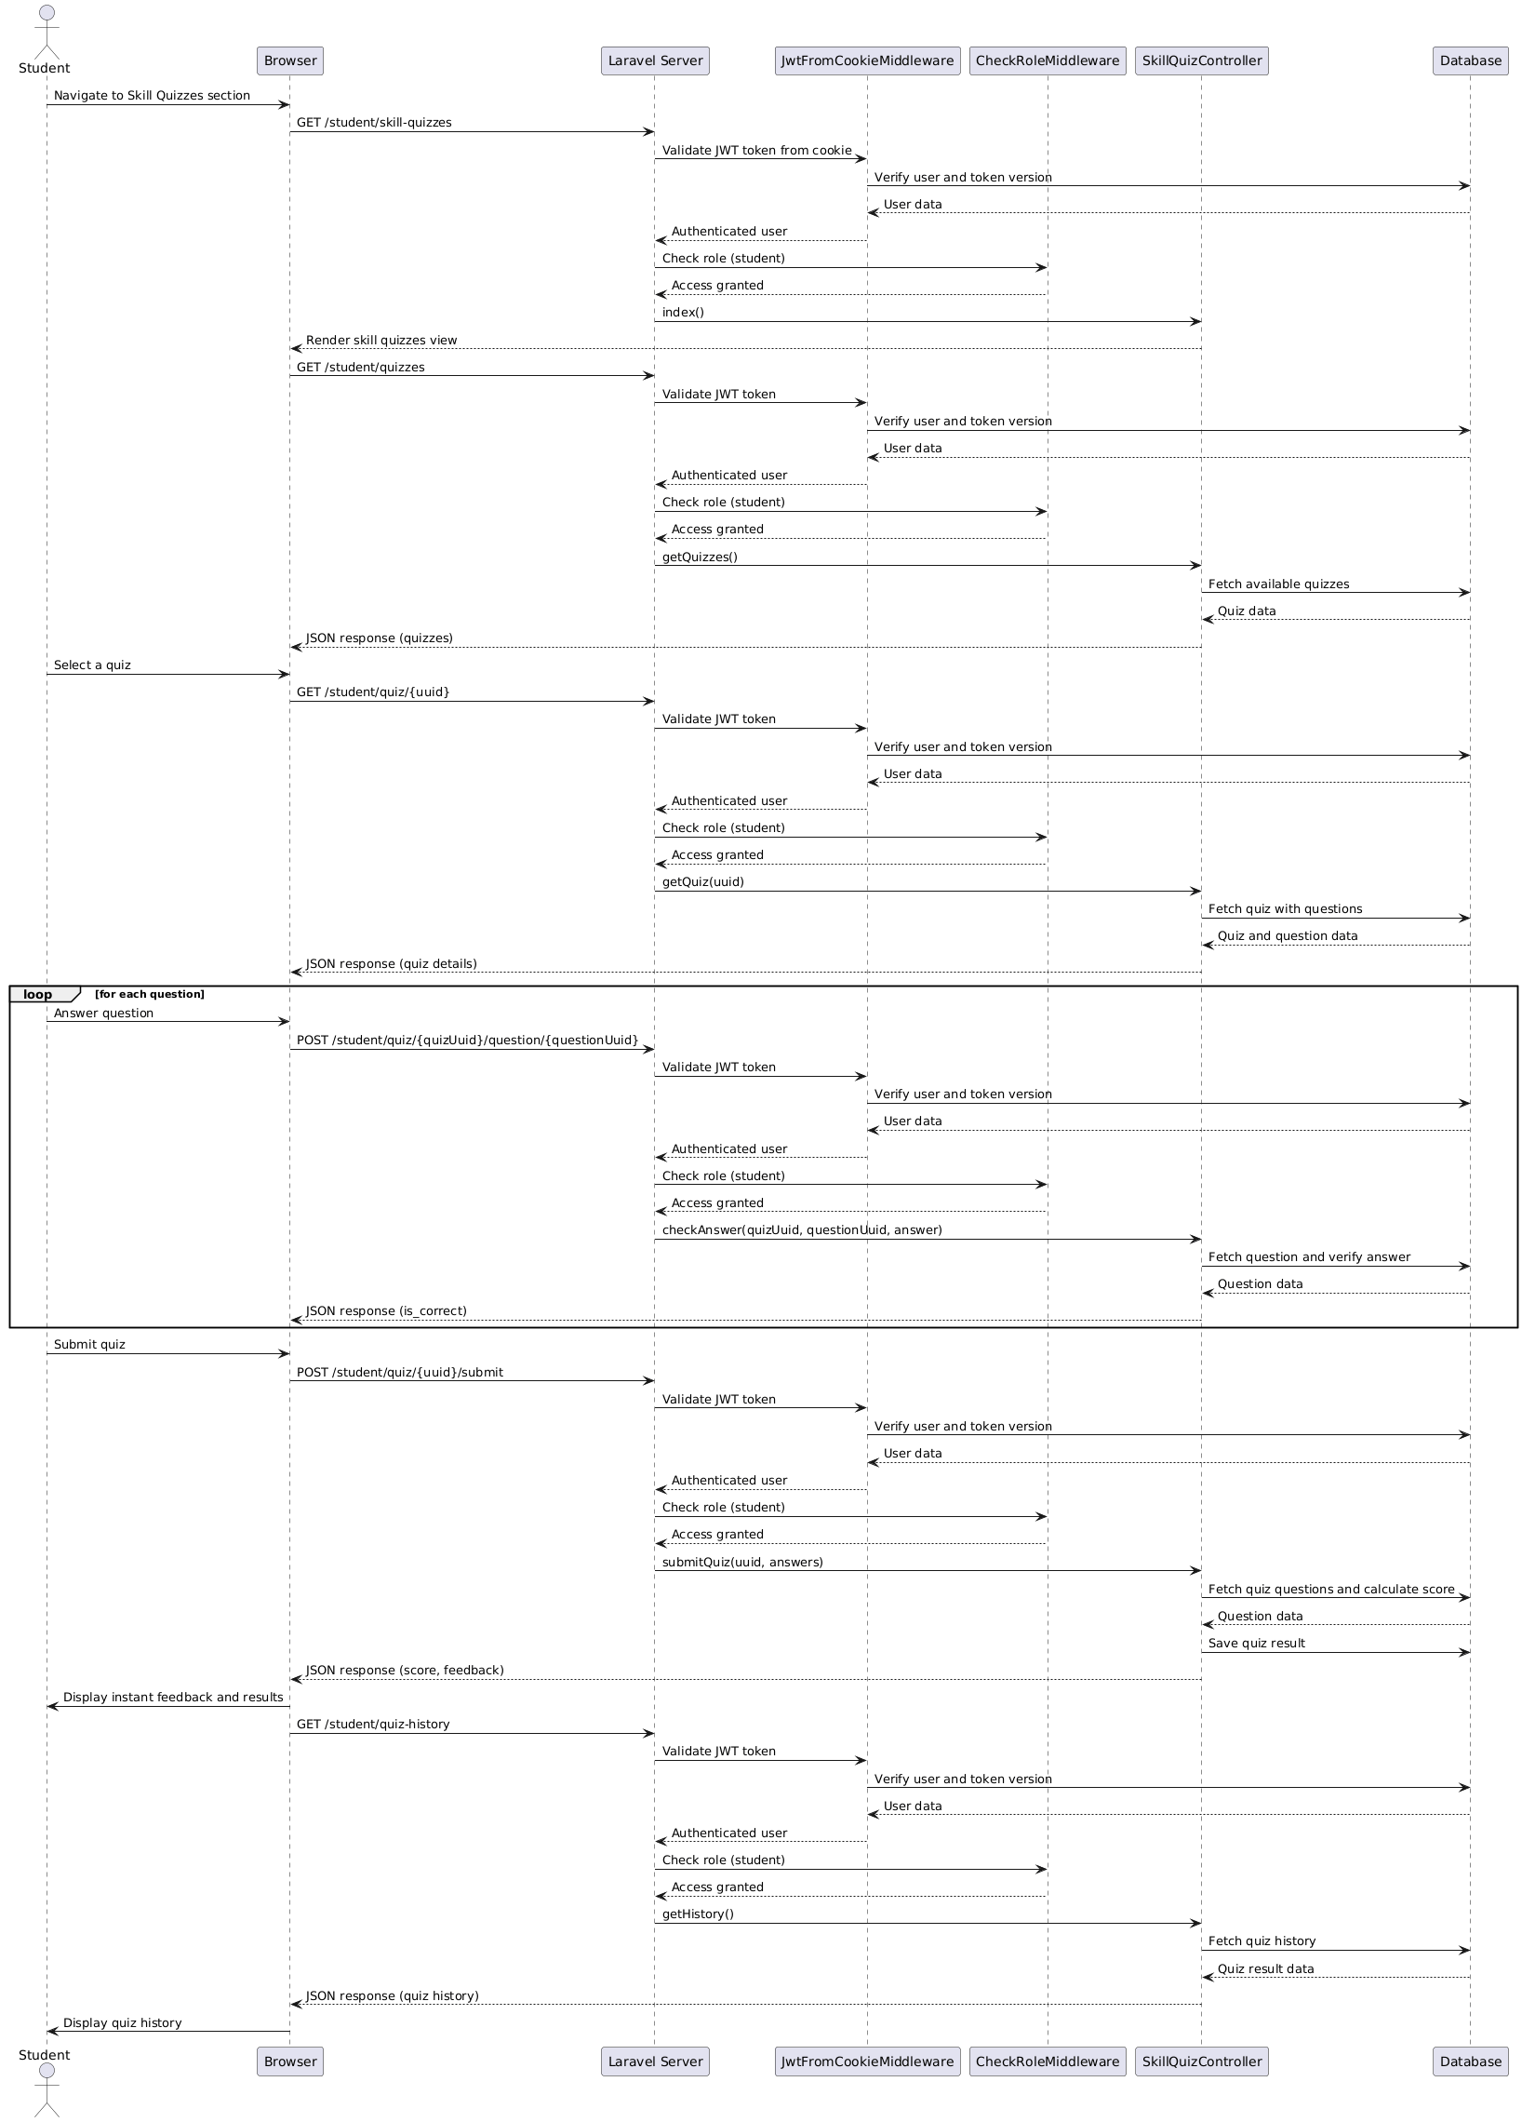

1. **Participate in Community Forum**

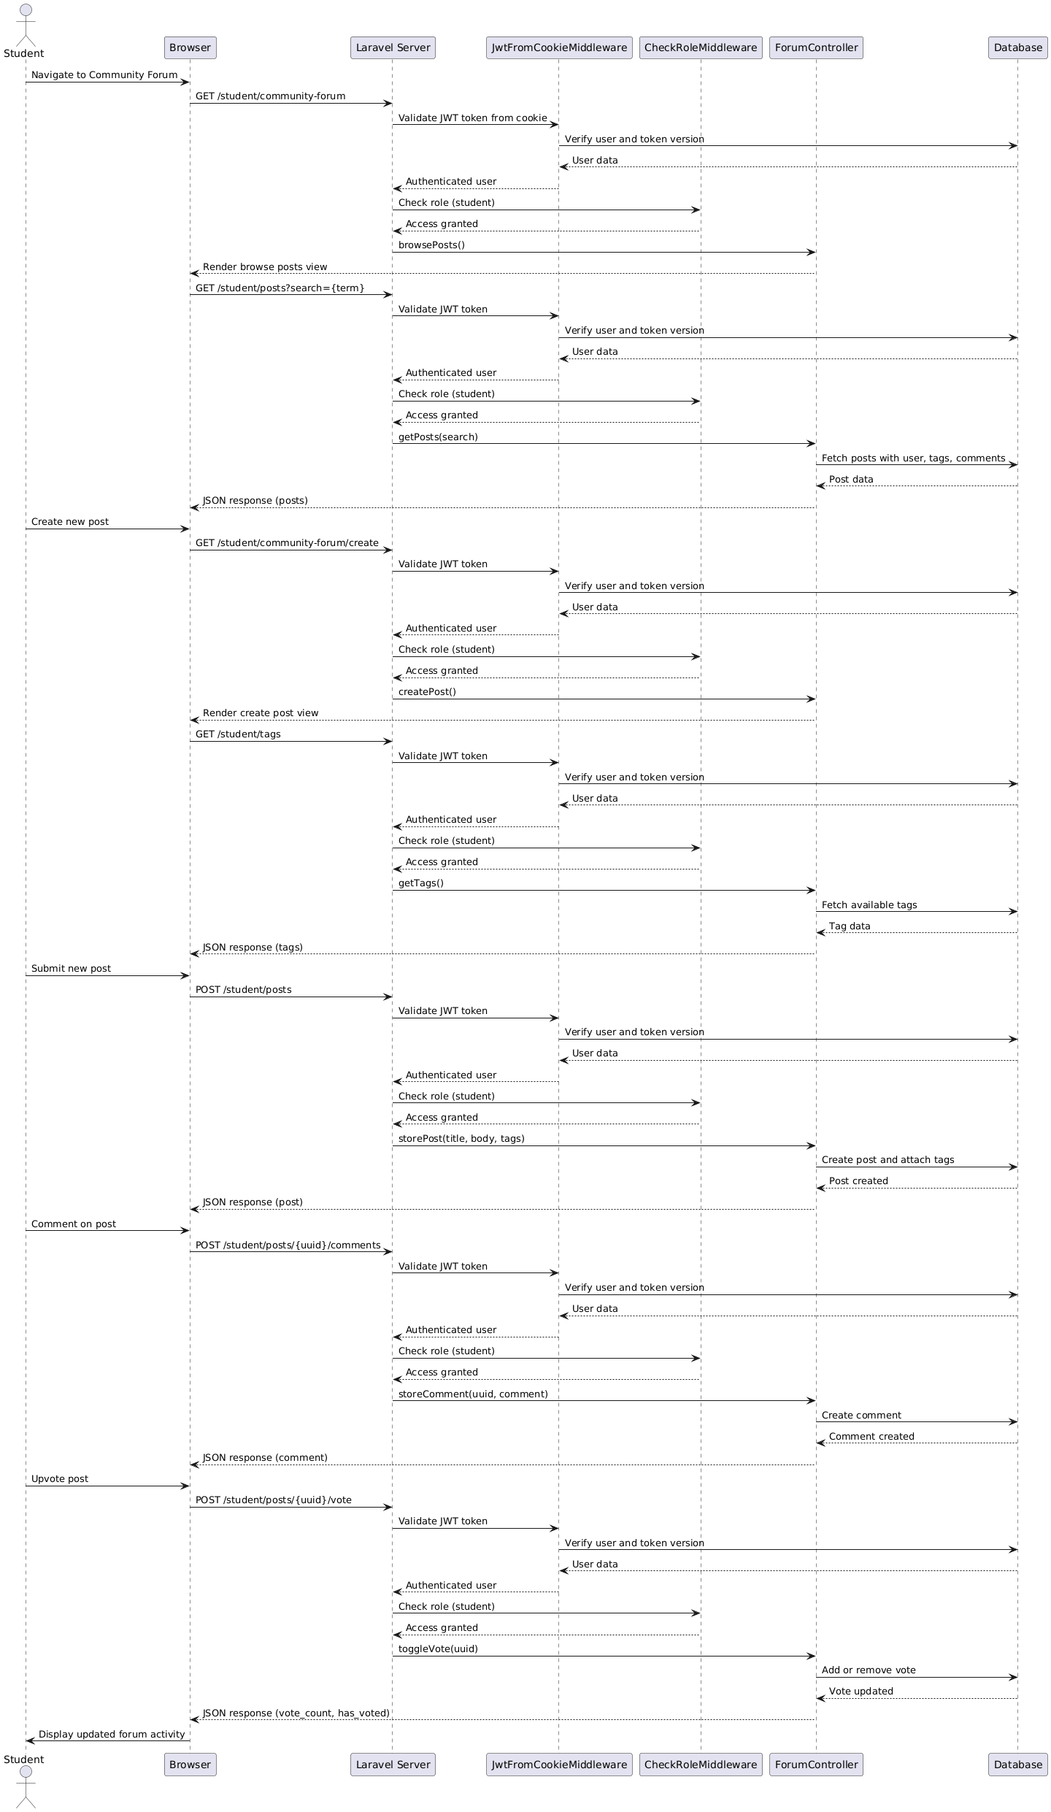

### 5.3.2 Mentor Use Cases

1. **Manage Mentor Profile**

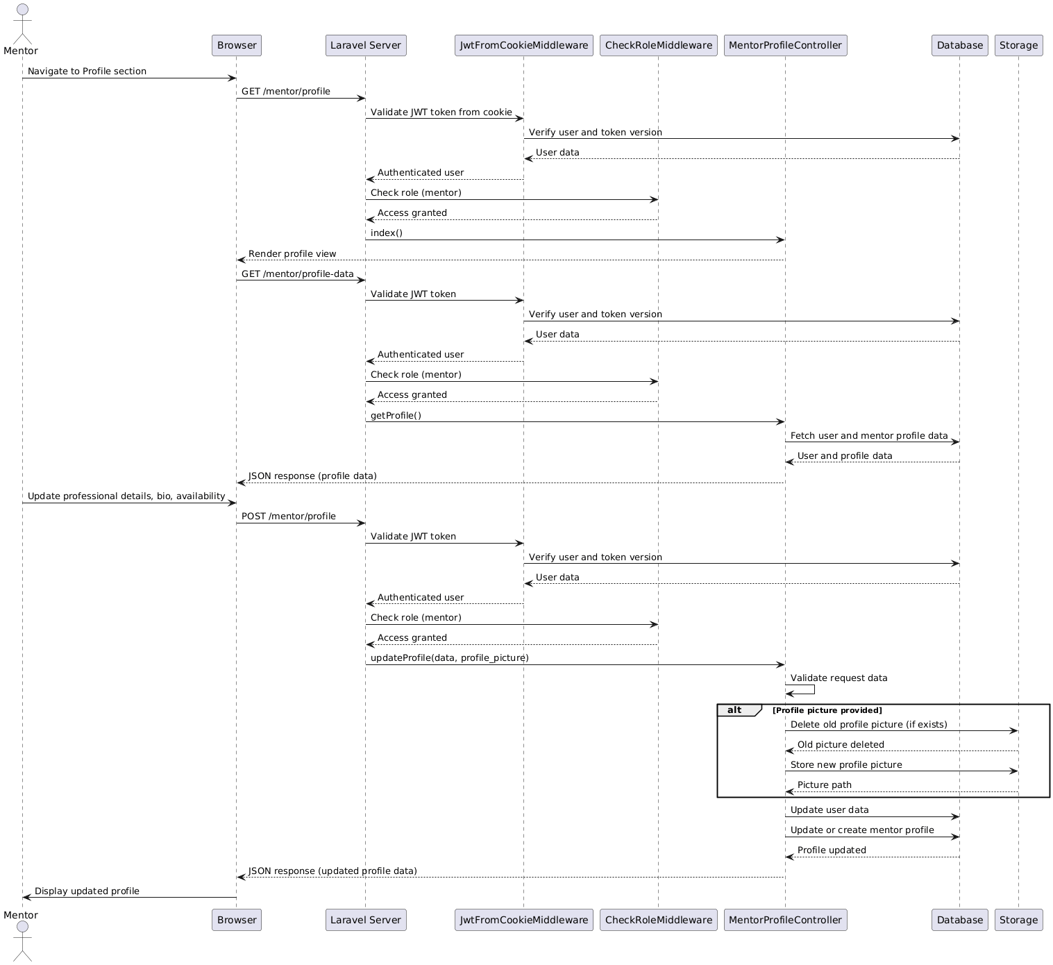

1. **Create and Manage Forum Posts**

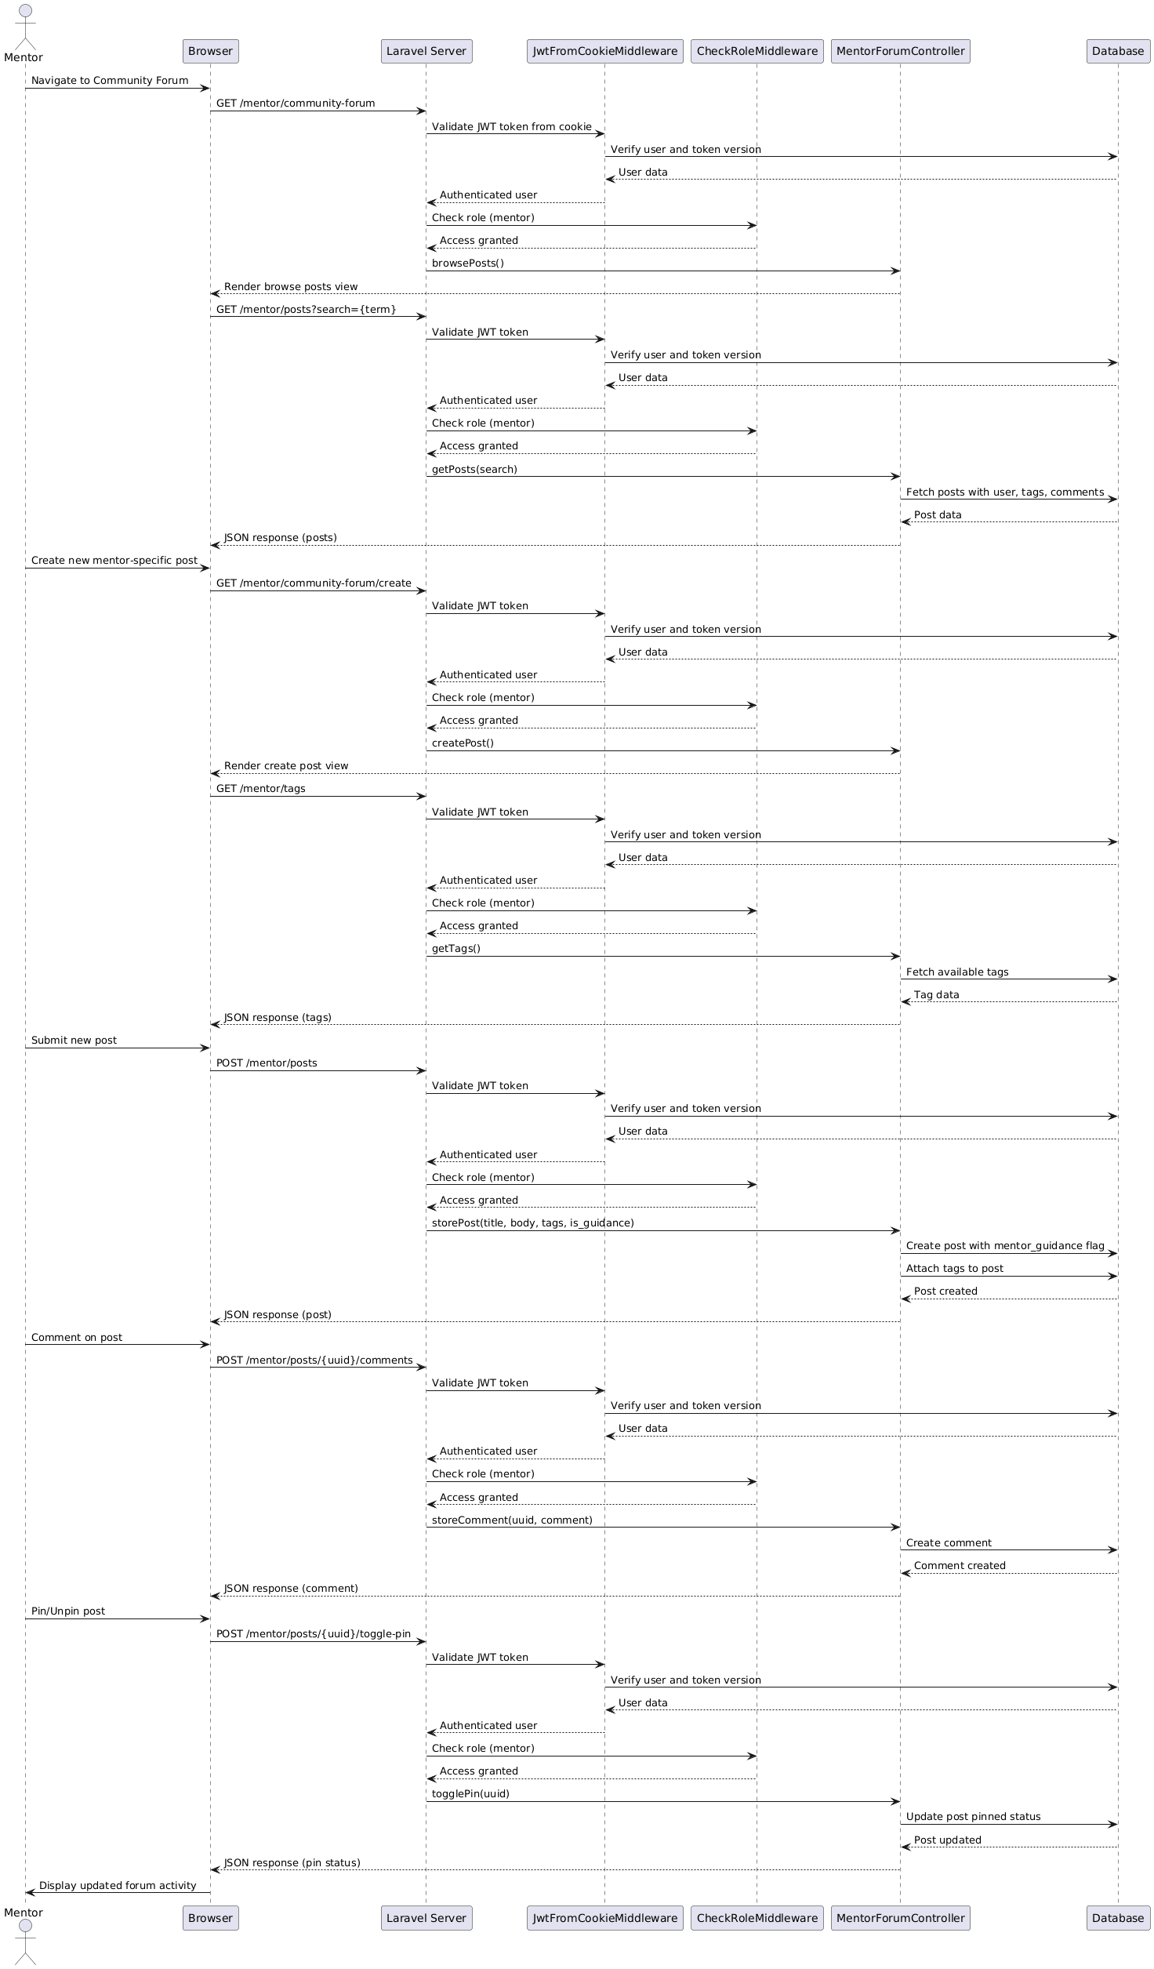

1. **View Interaction Analytics**

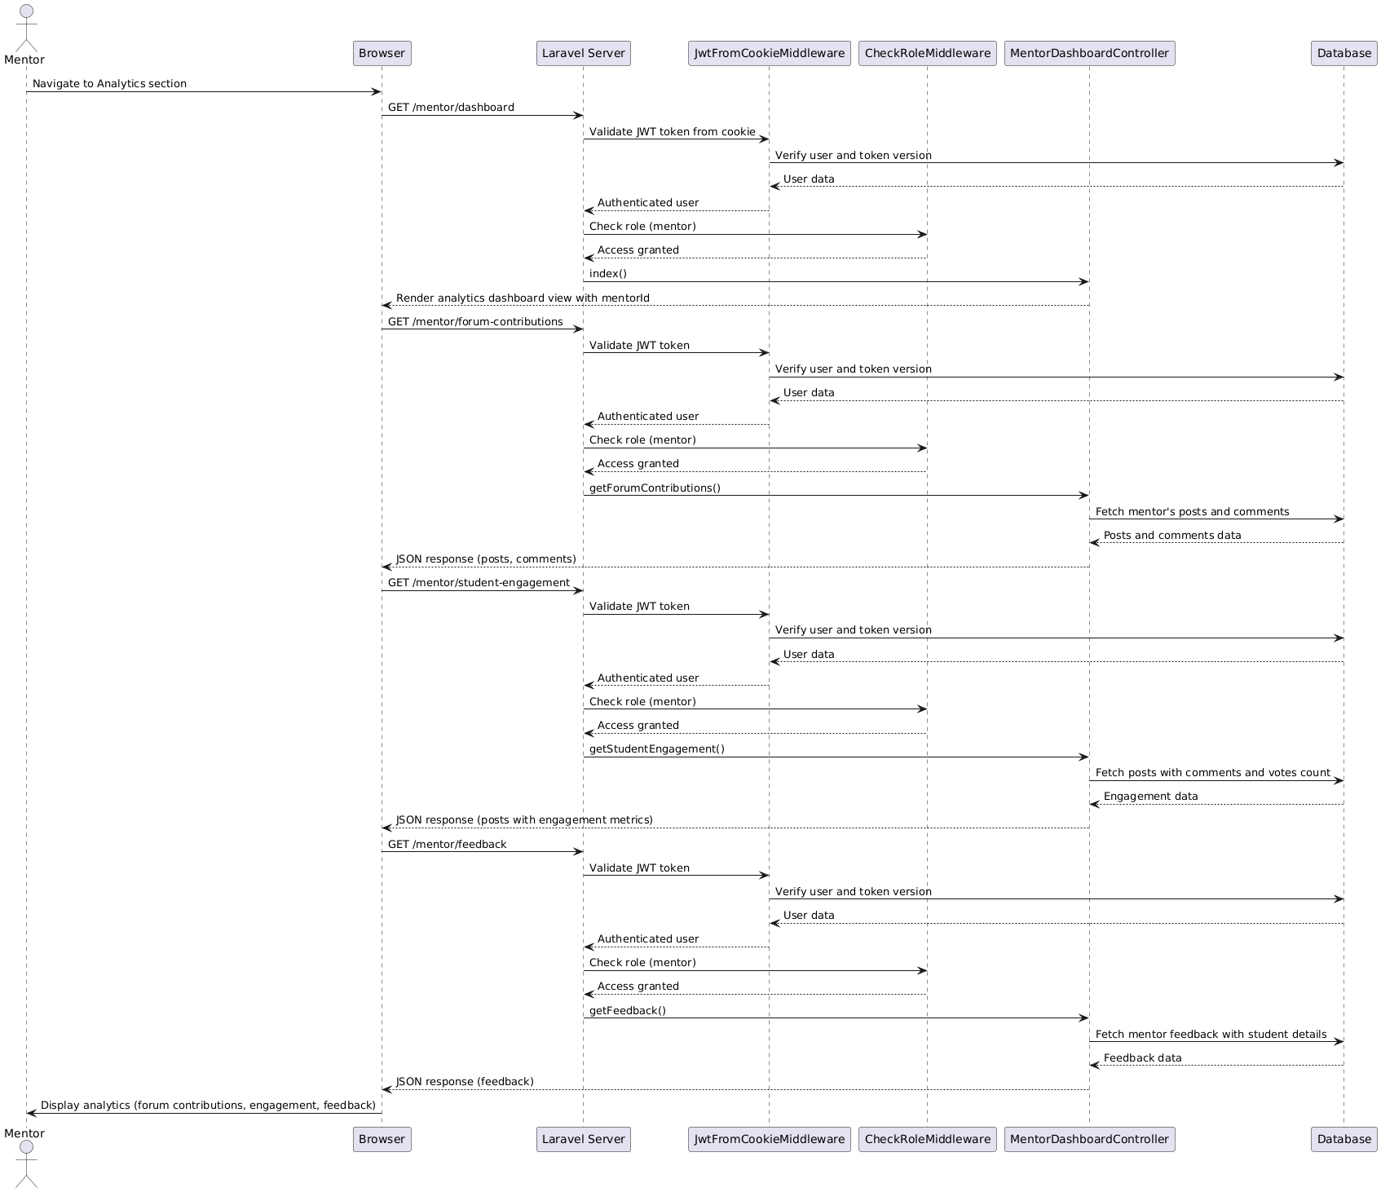

### 5.3.3 Admin use cases

1. **Approve/Reject Mentor Applications**

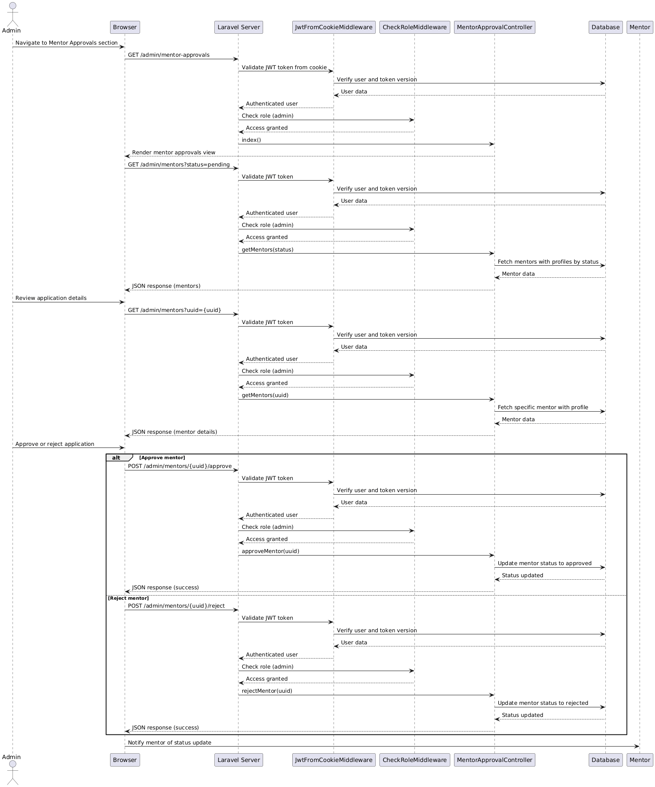

1. **Manage Users**

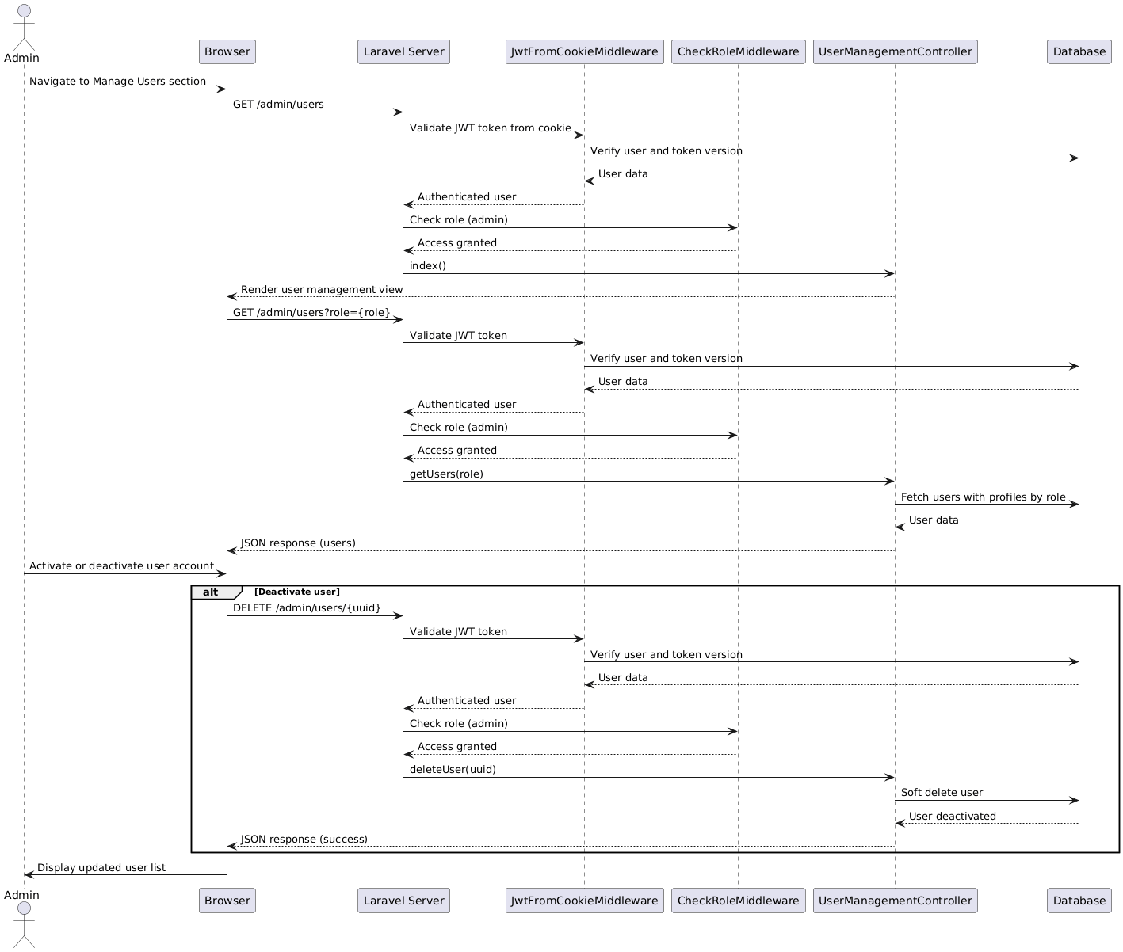

1. **Moderate Community Forum**

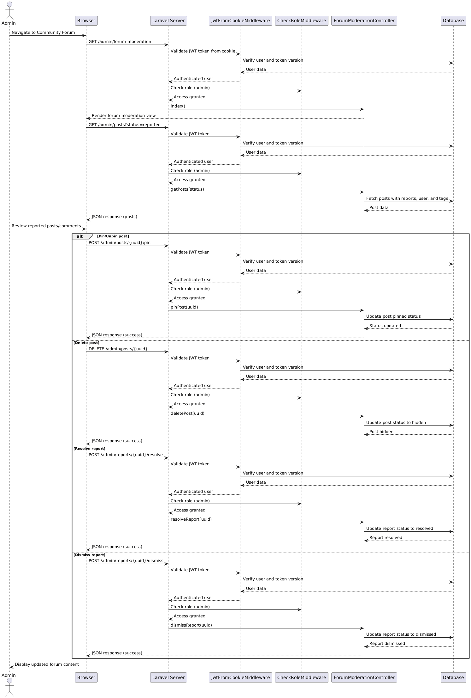

### 5.3.4 Career prediction

**1. Web-Based Career Recommendation Process**

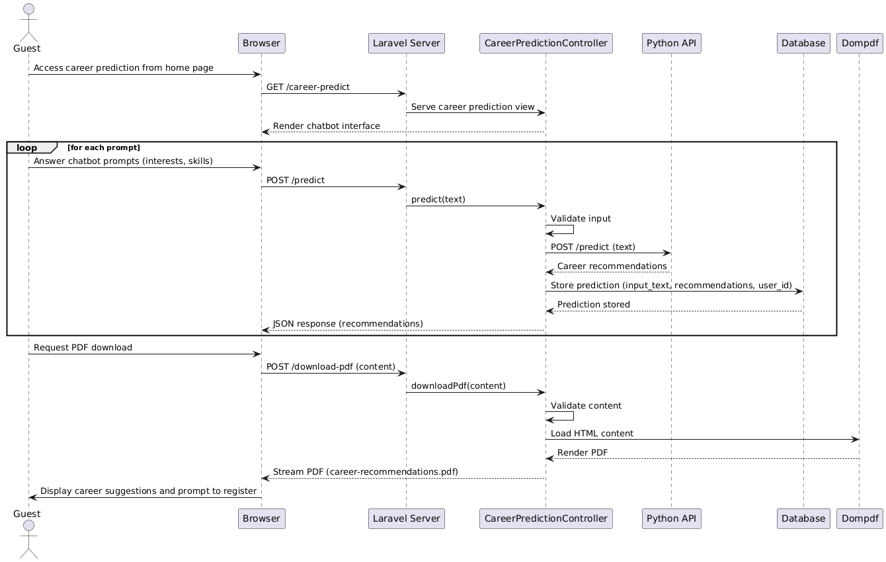

**2. Machine Learning Career Prediction Pipeline**

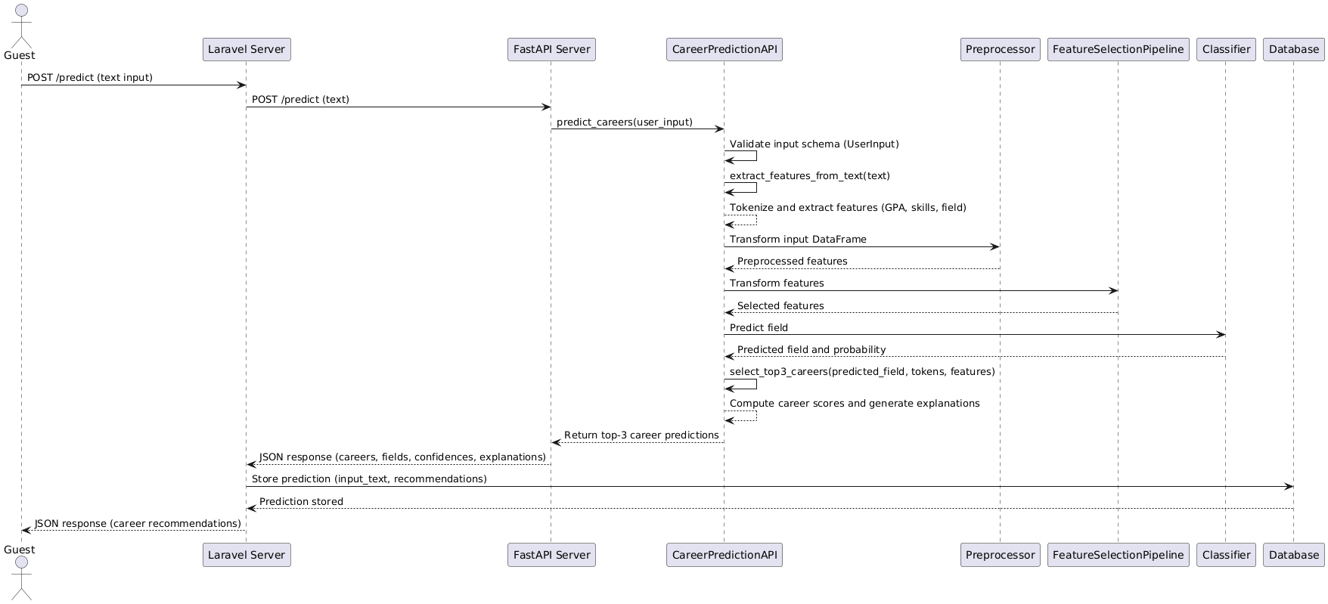

### 5.3.5 Login use case

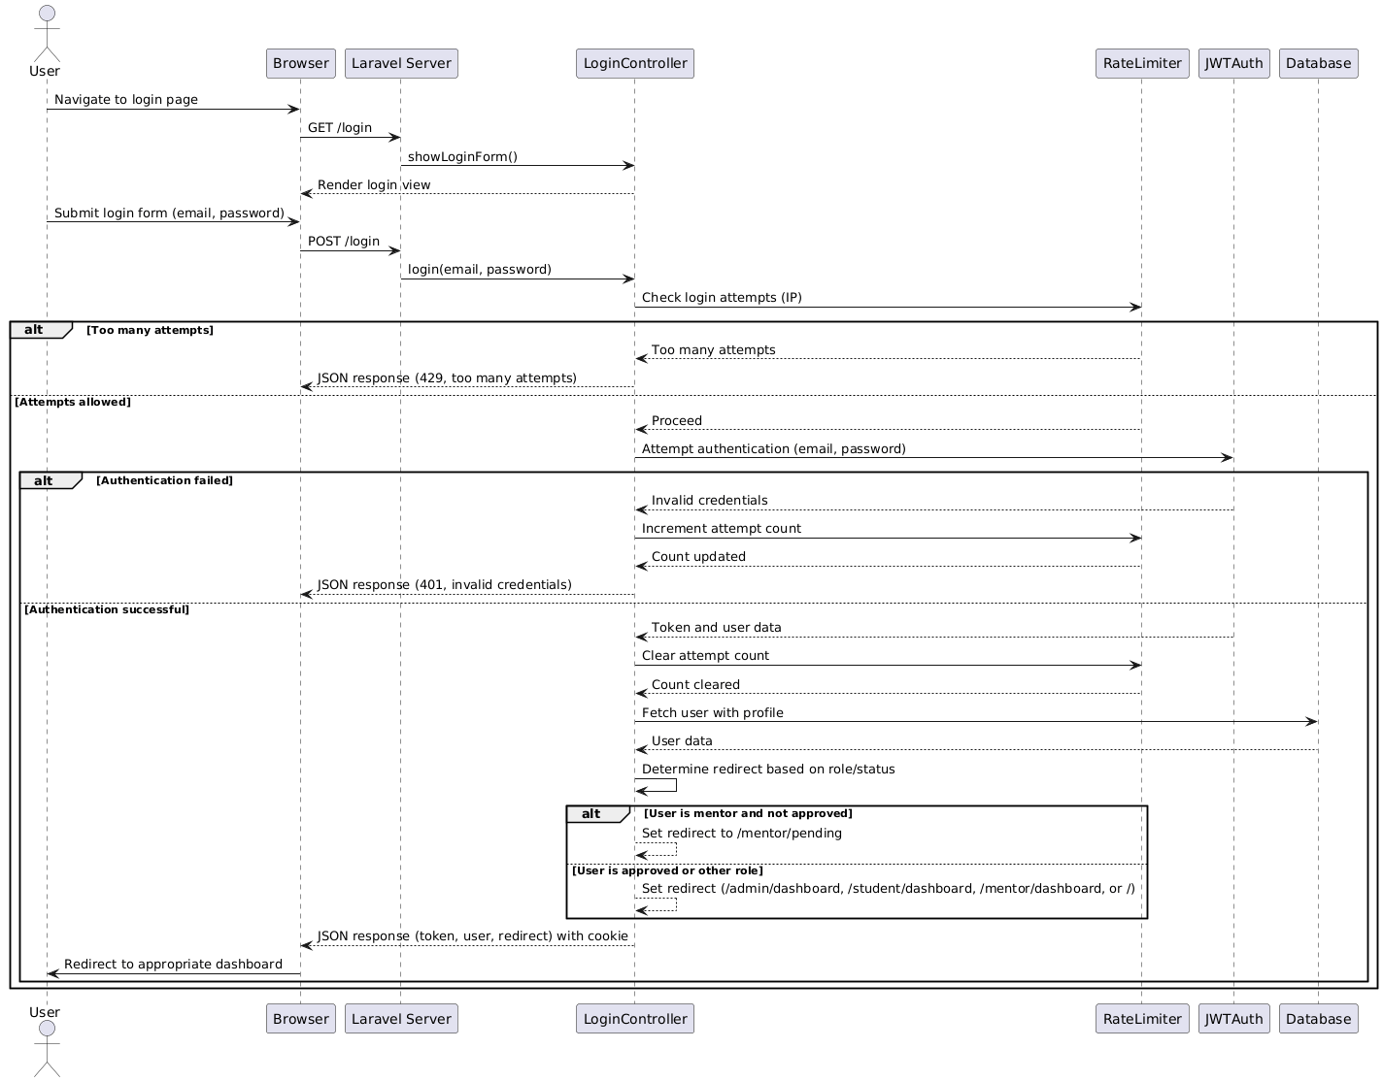

### 5.3.6 Reset password use case

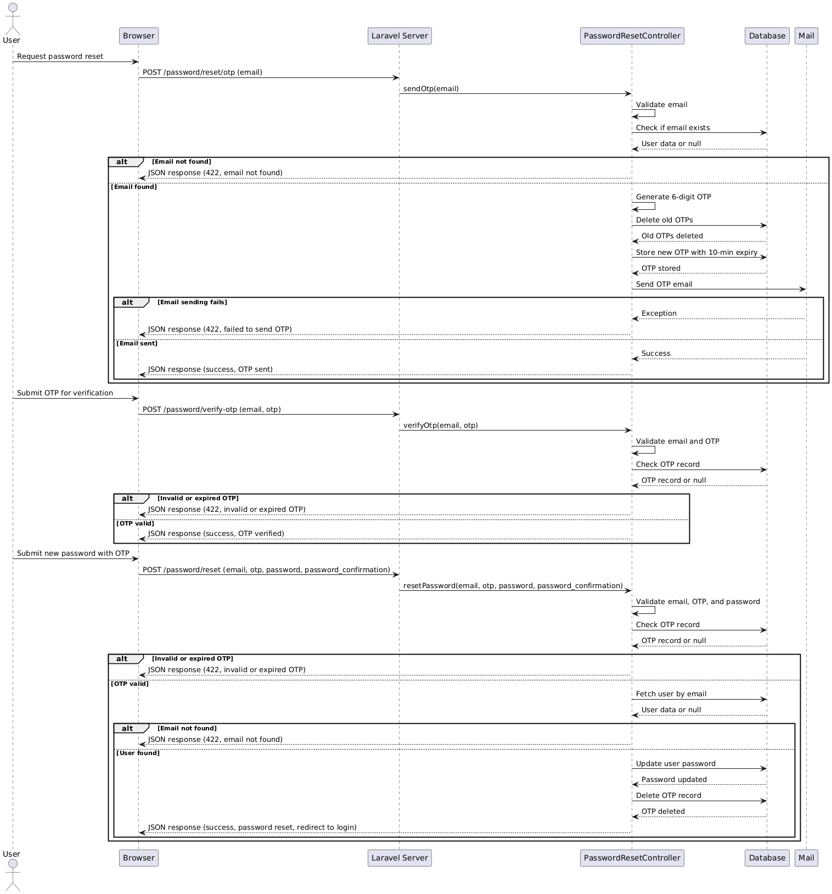

## 5.4 Class diagram

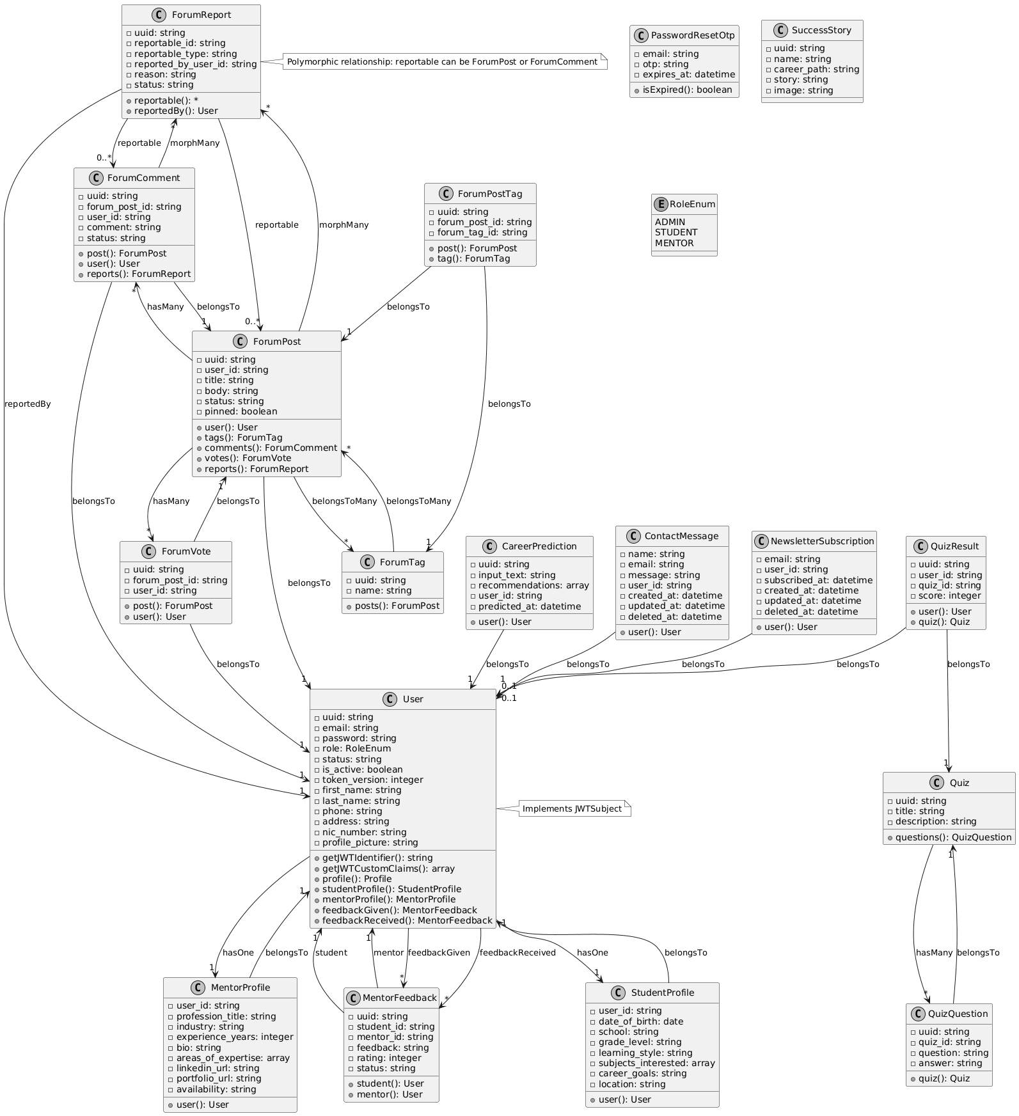

## 5.5 Use case diagram

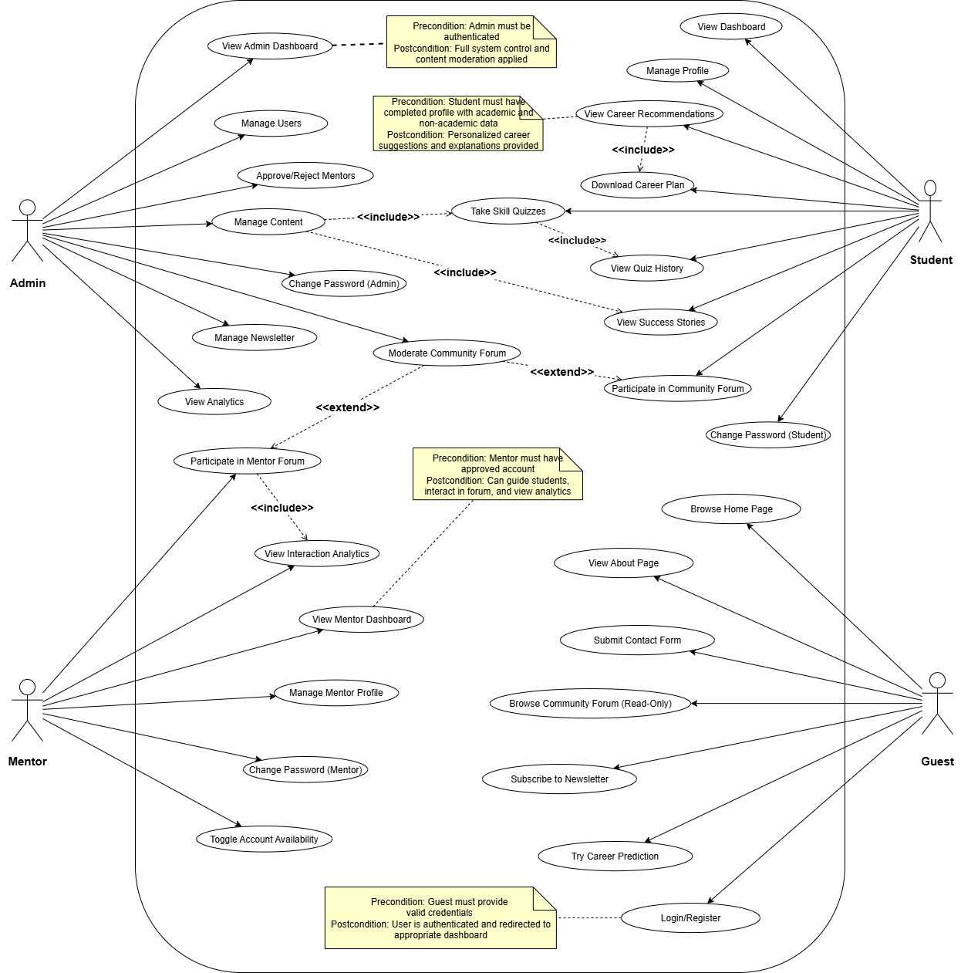

# 6. Implementation

## 6.1 Technology Stack

The CareerCompass project was developed using a combination of web development and machine learning technologies to deliver a robust, user-friendly career recommendation system. The technology stack was chosen to support rapid development, accurate career predictions, and a modular architecture suitable for an academic final-year project running in a local development environment. Below is a detailed overview of the tools, frameworks, libraries, and environments used, along with the rationale for their selection.

### 6.1.1 Frontend Technologies

* **HTML5, CSS3, JavaScript**: Used to create the user interface, including the landing page, chatbot-style career prediction interface, and interactive dashboards for Students, Mentors, and Admins.
* **Bootstrap 5**: Employed for responsive and consistent styling across devices (desktops, smartphones with minimum resolution 320x480px). Bootstrap was chosen for its ease of use, pre-built components, and ability to create a polished UI with minimal effort, ideal for an academic project.
* **jQuery 3.6**: Utilized for dynamic client-side interactions, such as form validation, AJAX calls to the Laravel backend, and handling the chatbot-style career prediction flow. Selected for its simplicity and compatibility with Laravel’s frontend ecosystem.

**Rationale**: These technologies ensure a responsive, interactive, and accessible interface, aligning with the project’s usability requirements (NFR-4). Bootstrap and jQuery reduce development time, allowing focus on backend and ML integration.

### 6.1.2 Backend Technologies

* **Laravel 11**: A PHP framework used for the server-side application, handling user authentication, role-based access control, and core features like dashboards, forums, and quiz management. Laravel was chosen for its robust MVC architecture, built-in authentication (via JWT), and rapid development capabilities, making it suitable for academic timelines.
* **PHP 8.2**: The programming language powering Laravel, providing modern features like type safety and performance improvements.
* **DomPDF 3.1**: A PHP library used to generate PDF reports for career plans, enabling Students to download personalized recommendations. Selected for its seamless integration with Laravel and ability to handle text and basic formatting.
* **PHP-Open-Source-Saver/JWT-Auth 2.3**: Used for JSON Web Token (JWT)-based authentication, securing API routes and managing user sessions. Chosen for its compatibility with Laravel and support for role-based access control.

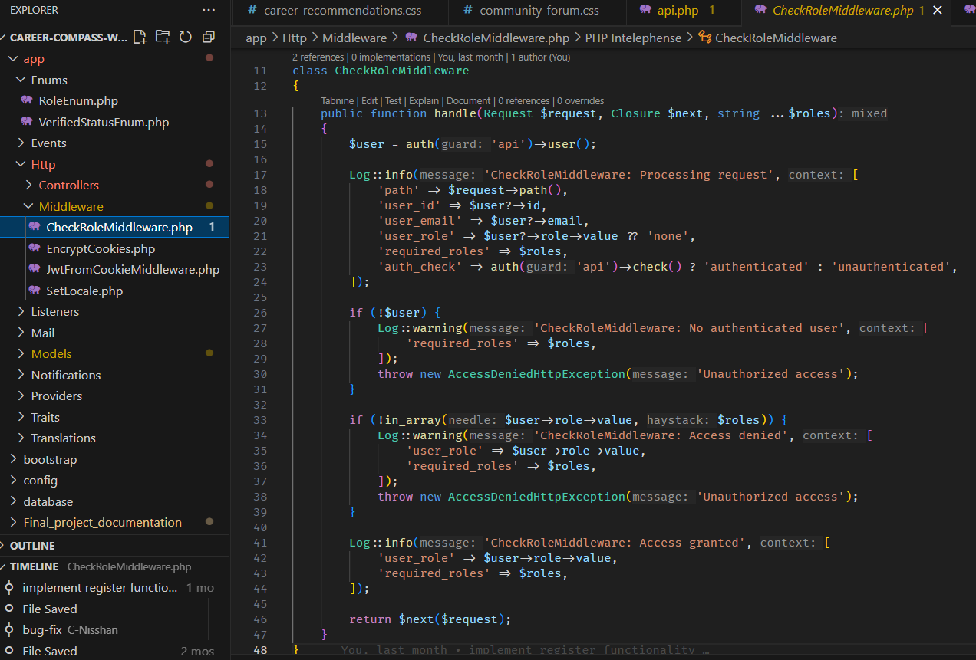

**Rationale**: Laravel’s ecosystem, combined with PHP’s reliability and DomPDF’s PDF generation, supports the project’s functional requirements (e.g., FR-S3, FR-C1) and ensures secure, modular backend development. JWT-Auth provides robust authentication for Students, Mentors, and Admins, critical for role-based features.

### 6.1.3 Machine Learning Service

* **FastAPI 0.95**: A Python-based framework used to build the machine learning service, exposing a RESTful API for career predictions. Selected for its high performance, asynchronous capabilities, and ease of integration with Laravel via HTTP requests.
* **Python 3.9**: The programming language for the ML service, chosen for its extensive ML ecosystem and compatibility with FastAPI.
* **LightGBM 3.3**: A gradient boosting framework used for the career recommendation model, leveraging its high accuracy and efficiency for classification tasks. Chosen to meet the ≥80% accuracy requirement (NFR-3) based on its performance with structured datasets
* **pandas 1.5, scikit-learn 1.2**: Used for data preprocessing, feature extraction, and model training. pandas handled dataset manipulation while scikit-learn provided tools for feature selection (e.g., VarianceThreshold, SelectKBest) and pipeline creation.
* **NLTK 3.7**: Utilized for natural language processing tasks, such as tokenizing user input and extracting features for the ML model (e.g., interests, skills). Selected for its robust text processing capabilities.
* **joblib 1.2**: Used to save and load ML artifacts (e.g., preprocessor, classifier, feature names) for efficient model deployment.

**Rationale**: FastAPI and Python provide a lightweight, high-performance ML service that integrates seamlessly with Laravel via API calls. LightGBM ensures accurate career predictions, while pandas, scikit-learn, and NLTK support robust data processing and feature extraction, critical for handling diverse inputs (e.g., RIASEC traits, academic data).

### 6.1.4 Database

* **MySQL 8.0**: A relational database used to store user data (e.g., profiles, quiz results, forum posts), content (e.g., success stories, quiz questions), and analytics data. Chosen for its compatibility with Laravel, reliability, and support for complex queries.
* **MySQL Workbench 8.0**: Used for database management, including schema design and query testing. Selected for its user-friendly interface and integration with MySQL.

**Rationale**: MySQL’s relational structure supports the project’s data requirements (e.g., FR-S2, FR-A4) and is well-suited for a local development environment, while MySQL Workbench simplifies database administration for an academic project.

### 6.1.5 Development Environment

* **Local server** : A local server environment used to run the Laravel backend and MySQL database. Chosen for its ease of setup and widespread use in academic projects.
* **Visual Studio Code 1.85**: The primary IDE for coding, debugging, and version control, with extensions for PHP, Python, and Laravel support. Selected for its lightweight nature and extensive plugin ecosystem.
* **Git 2.39**: Used for version control to manage source code and track changes. Hosted locally or on a platform like GitHub for backup.

**Rationale**: Local development server and VS Code provide a robust, free development environment suitable for a final-year project, while Git ensures code management

### 6.1.6 Other Tools

* **PHPUnit 10.5**: A testing framework included in Laravel for unit and feature testing of backend functionality (e.g., API endpoints, middleware). Chosen for its integration with Laravel and ability to validate functional requirements (e.g., FR-C1, FR-A2).
* **FakerPHP 1.23**: Used to generate synthetic test data for database seeding and testing, simulating user profiles and quiz responses. Selected to mimic real-world data without privacy concerns.
* **Postman 10.15**: Used for testing API endpoints (e.g., FastAPI /predict, Laravel protected routes) and verifying integration between the backend and ML service.

**Rationale**: These tools support testing, data simulation, and API development, ensuring the system meets functional requirements and operates reliably in a local environment.

### 6.1.7 Why These Technologies?

The technology stack was carefully chosen to align with the project’s academic scope and objectives.

* **Laravel and PHP**: Enabled rapid development of a secure, role-based backend within the three-month timeline (NFR-10), leveraging Laravel’s built-in features like authentication and routing.
* **FastAPI and LightGBM**: Provided a high-performance ML service capable of achieving ≥80% recommendation accuracy (NFR-3), with FastAPI ensuring better integration with Laravel.
* **MySQL**: Offered a reliable, relational database for storing structured data, compatible with Laravel and suitable for local testing.
* **Bootstrap and jQuery**: Simplified frontend development, ensuring a responsive and user-friendly interface (NFR-4) without requiring advanced frameworks.
* **Development Tools**: Local Development server, VS Code, and Git are free, widely used, and student-friendly, minimizing setup complexity and costs.

## 6.2 Design Patterns

This section explains the design patterns used in CareerCompass to make the code organized, reusable, and easy to maintain. Design patterns are like blueprints that help structure the program. Since this is an academic project, we used simple and effective patterns that work well with Laravel and FastAPI. Below are the main patterns, why we used them, and how they were applied.

### 6.2.1 MVC Pattern

**What It Does**: The Model-View-Controller (MVC) pattern splits the program into three parts: Models handle data, Views show the user interface, and Controllers manage user requests.

**How We Used It**

* **Models**: We created models like ContactMessage and ForumVote to manage data in the MySQL database. These models use Laravel’s Eloquent to save and fetch data, like contact form submissions or forum votes.

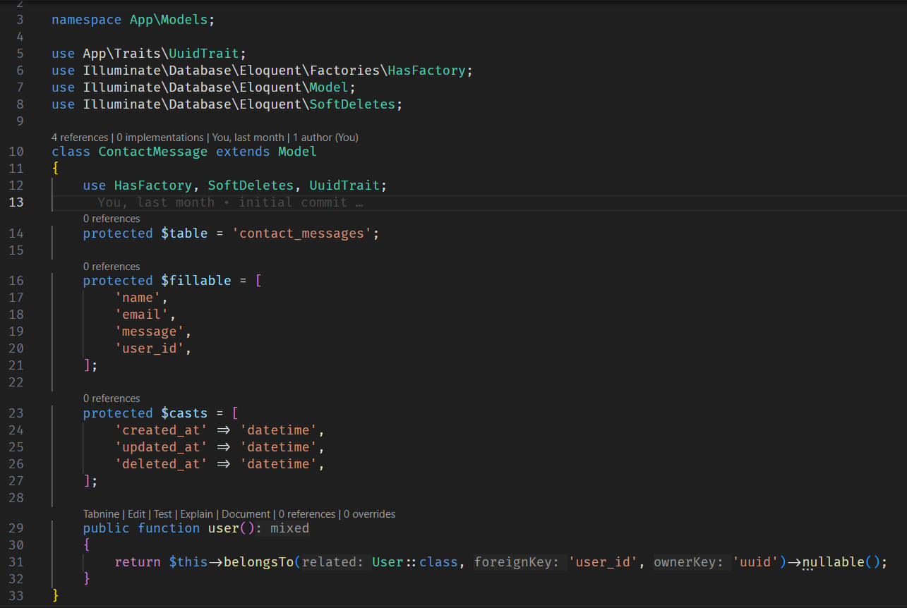

* **Views**: Blade templates, like contact.blade.php, create the user interface. For example, the contact form page shows input fields and sends data to the server using JavaScript.

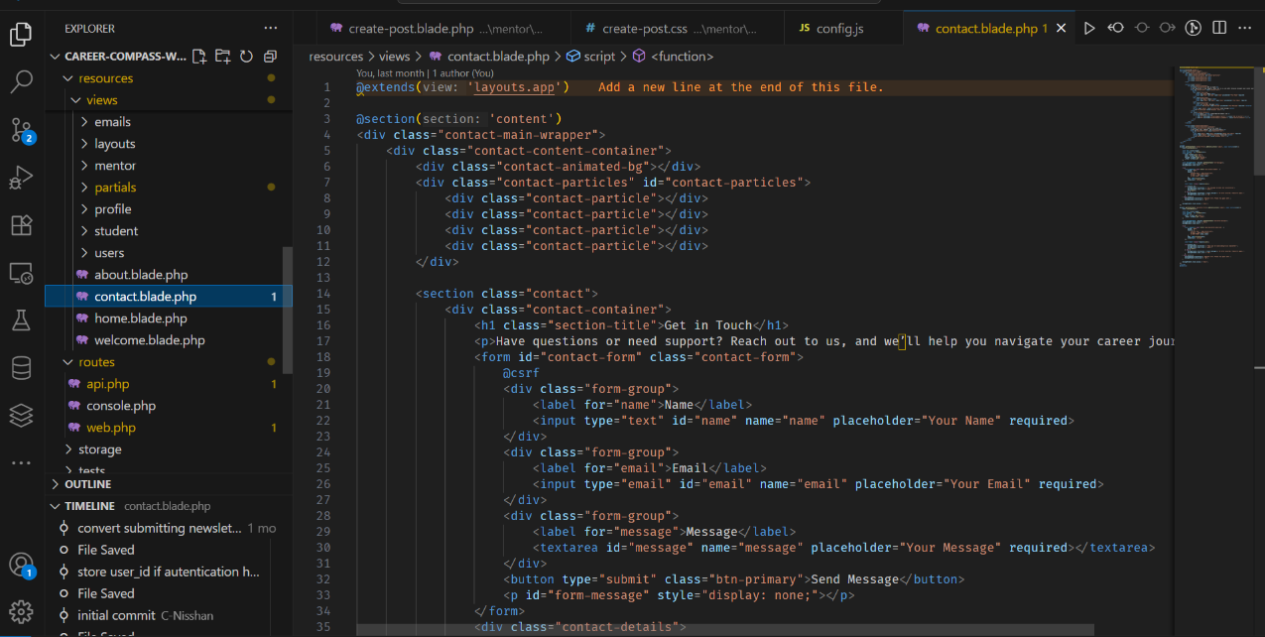

* **Controllers**: The ContactController handles form submissions, validates inputs, and saves data to the ContactMessage model. It also triggers emails (though mocked for local testing).

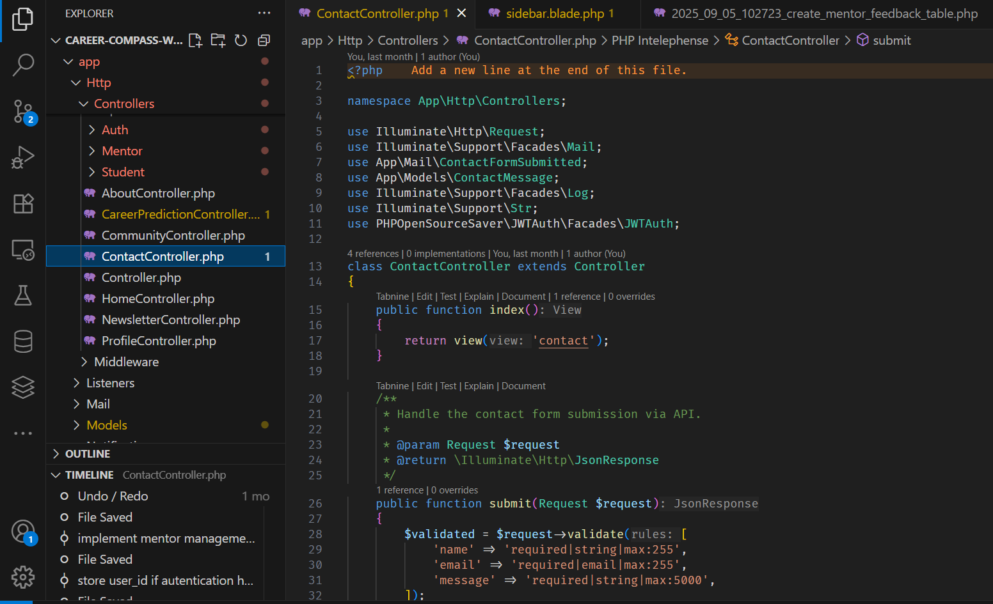

**Why We Chose It**: MVC is built into Laravel, making it easy to separate the logic (Controllers), data (Models), and display (Views). This kept the code clean and helped us build features like the contact form and dashboards quickly.

### 6.2.2 Active Record Pattern

**What It Does**: The Active Record pattern lets each model directly interact with the database. Each model object represents a row in a database table and can save, update, or delete itself.

**How We Used It**

* Models like ContactMessage and ForumVote use **Laravel’s Eloquent ORM** to interact with MySQL tables. For example, **ContactMessage:create()** saves a new contact form submission to the contact_messages table.

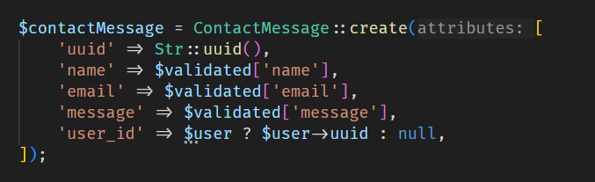

* Relationships are defined in models, like ContactMessage linking to a User via **belongsTo,** making it easy to fetch related data (e.g., the user who sent a message).

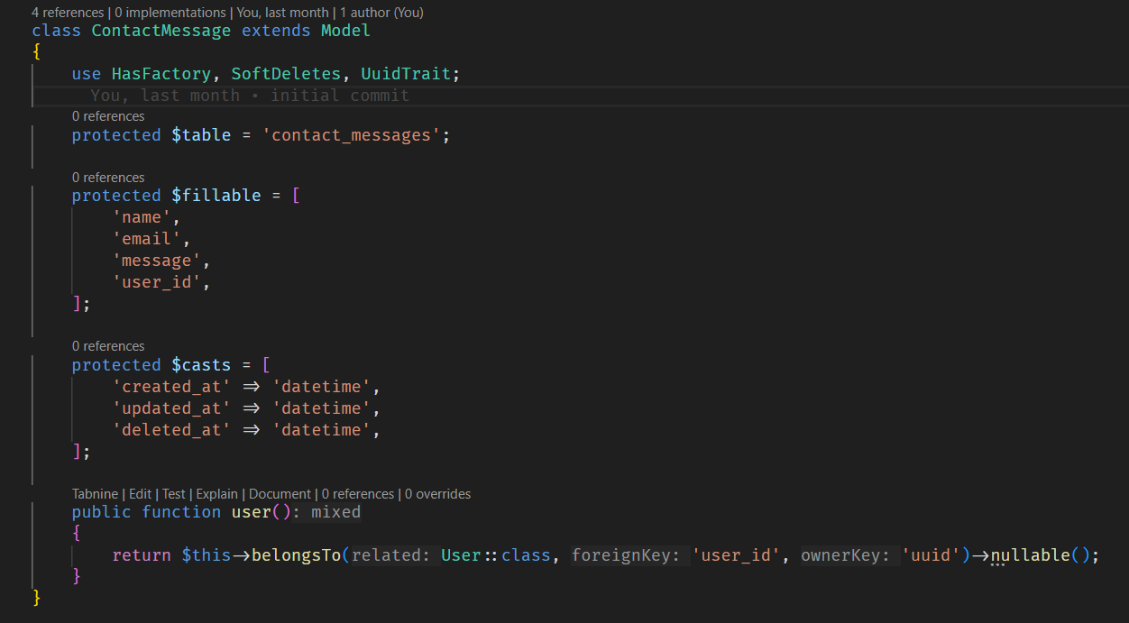

**Why We Chose It**: Active Record is Laravel’s default way to handle database operations. It’s simple to use and reduces the need for extra code, which is great for a student project with a tight timeline.

### 6.2.3 Factory Pattern

**What It Does**: The Factory pattern creates test data for the database, making it easy to simulate users and other records during development and testing.

**How We Used It**

* The **UserFactory** class generates fake user data (e.g., names, emails) using **FakerPHP**. For example, it creates users with random names and hashed passwords for testing features like login and profile management.

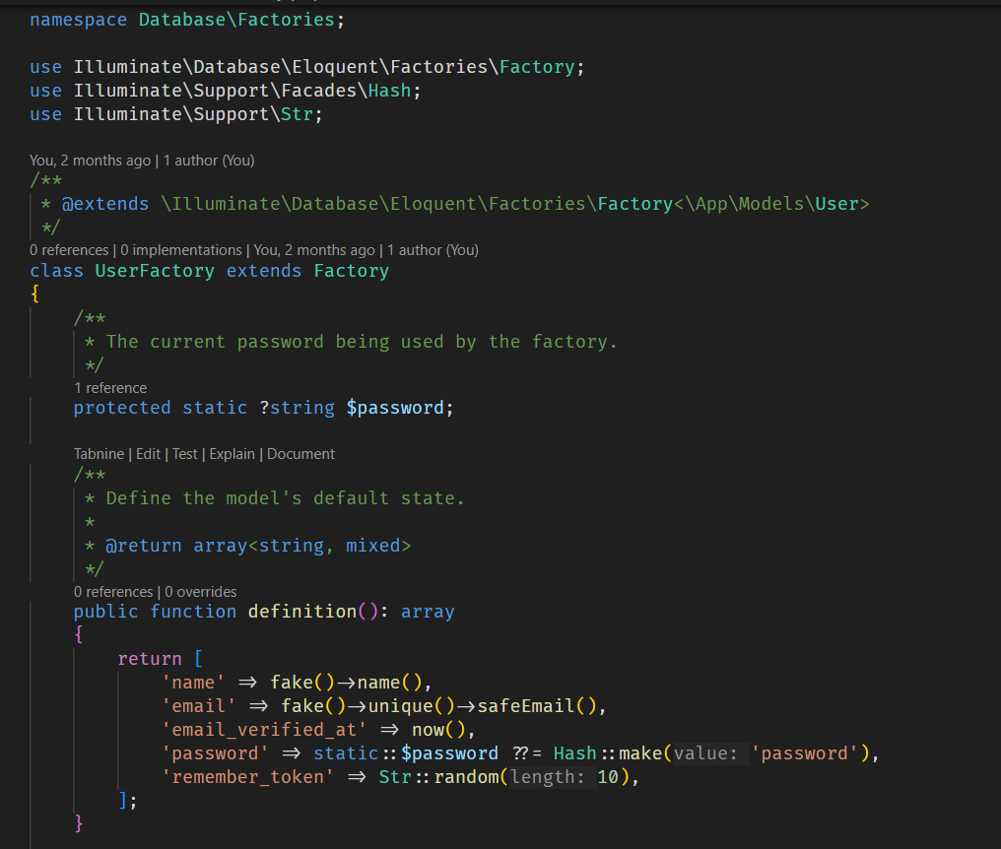

* We used factories to seed the database with sample data, such as users for testing the career recommendation system or forum posts.

**Why We Chose It**: Factories save time by creating realistic test data without manual entry. They helped us test features like career predictions and forum interactions without needing real users.

### 6.2.4 Trait Pattern

**What It Does**: The Trait pattern allows reusable code to be shared across multiple models or classes, avoiding duplication.

**How We Used It**

* The **UuidTrait** generates unique UUIDs for models like ContactMessage and ForumVote. Instead of auto-incrementing IDs, we **used UUIDs as primary keys** to ensure uniqueness (e.g., **uuid** field in ForumVote).
* The trait automatically assigns a UUID when a new record is created, checking for uniqueness to avoid conflicts.

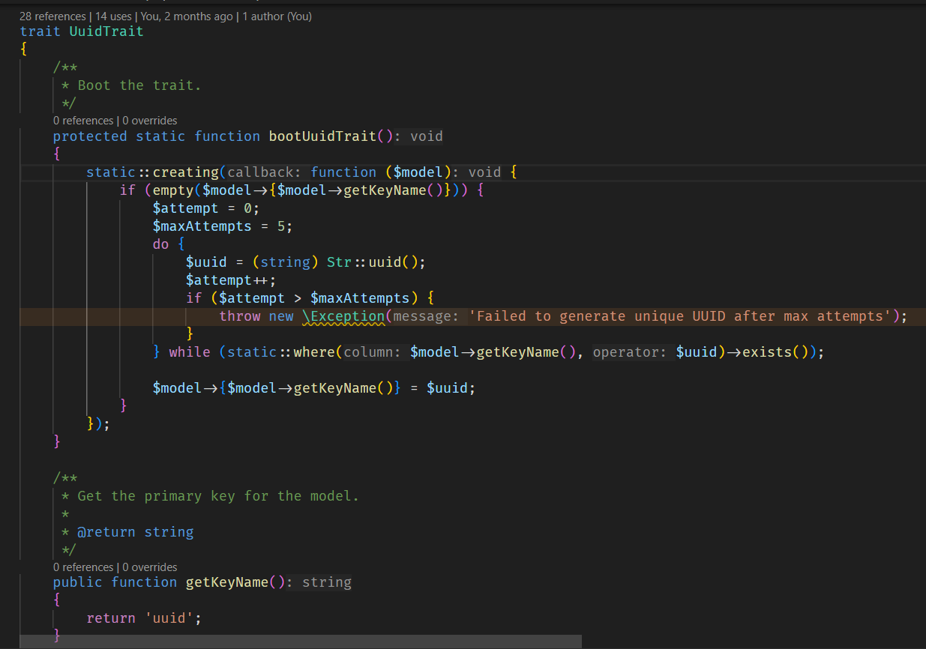

**Why We Chose It**: Traits make the code cleaner by reusing UUID logic across models. This was useful for ensuring unique identifiers in a local database, especially for features like forum posts and contact messages.

### 6.2.5 Observer Pattern

**What It Does**: The Observer pattern triggers actions (listeners) when specific events happen, like sending emails after a user registers or submits a form.

**How We Used It**

* Laravel’s event-listener system was used for email notifications. For example
  + The UserRegistered event triggers the SendVerificationEmail listener to send a verification email (mocked for local testing).

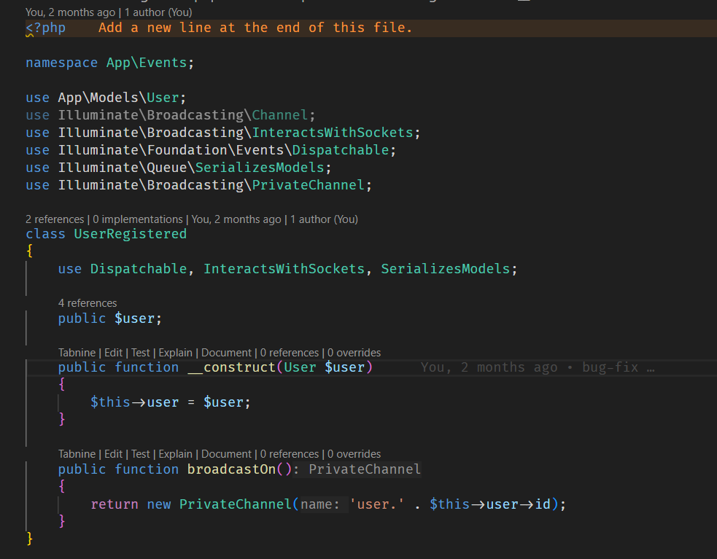

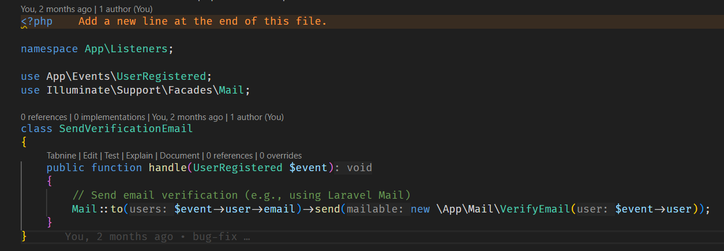

* + The ContactFormSubmitted mailable sends a confirmation email when a contact form is submitted (stored locally due to no real-time hosting).
  + The RegistrationStatus mailable notifies mentors about their application status (e.g., approved, rejected).
* These events ensure actions happen automatically, like notifying users without extra controller code.

**Why We Chose It**: The Observer pattern keeps the code modular by separating event handling (e.g., sending emails) from core logic. It was ideal for automating notifications in features like registration and contact forms.

### 6.2.6 Pipeline Pattern (FastAPI ML Service)

**What It Does**: The Pipeline pattern chains multiple processing steps to transform data, often used in machine learning workflows.

**How We Used It**

* In the FastAPI ML service, a scikit-learn Pipeline combines feature preprocessing (e.g., preprocessor, var_threshold, select_k_best) and classification (classifier) for career predictions.
* User inputs (e.g., text from the chatbot) are processed through this pipeline to extract features (e.g., GPA, skills) and predict career fields.

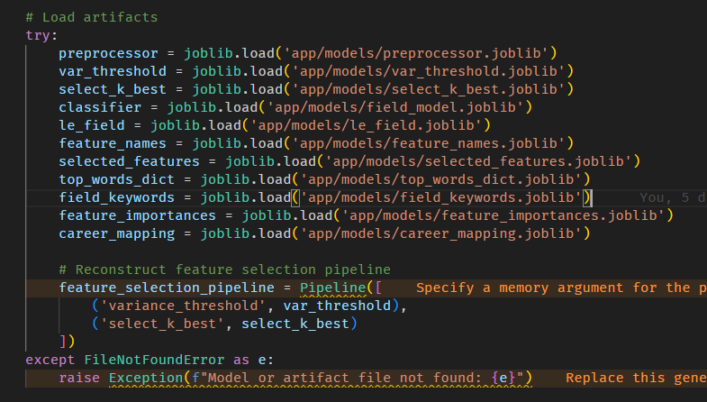

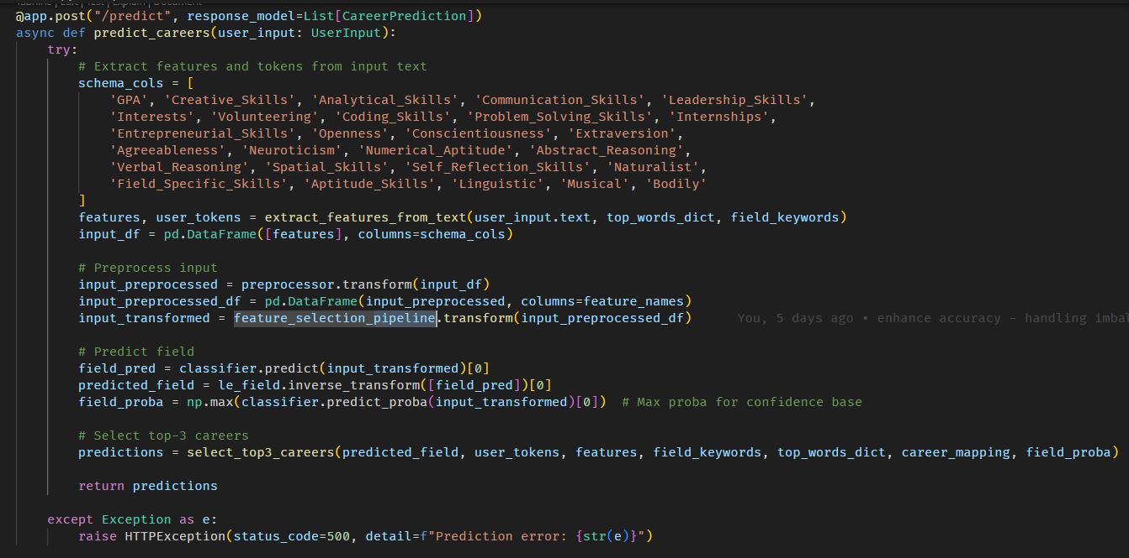

**Why We Chose It**: The Pipeline pattern organizes ML processing into clear steps, making it easier to debug and maintain. It ensures consistent feature extraction and prediction, helping achieve the ≥80% accuracy goal (NFR-3).

**Benefits of These Patterns**

* **MVC**: Made the code easier to manage by separating data, logic, and display, speeding up development.
* **Active Record**: Simplified database operations, letting us focus on features like quizzes and forums.
* **Factory**: Saved time by generating test data for development and testing.
* **Trait**: Reduced code duplication for UUID generation across models.
* **Observer**: Automated notifications, keeping the code clean and modular.
* **Pipeline**: Ensured reliable ML predictions by organizing data processing steps.

## 6.3 Implementation of the Program

This section explains how we built CareerCompass, a web-based career recommendation system for a final-year project. It covers the main parts of the system, how we coded it, how the web and machine learning parts connect, how we handled data, and the problems we faced. The system was developed and tested locally using local server, with no real-time hosting.

**Key Components**

CareerCompass has several main parts, each built to meet specific user needs (Guests, Students, Mentors, Admins). Below are the key features and how we implemented them.

### 6.3.1 Home and other Guest Pages

* **What It Does**: The home page welcomes users with an introduction to CareerCompass and buttons to log in, register, or try the career predictor. The about page explains the platform’s mission and benefits.
* **How We Built It**: Used Laravel’s Blade templates, styled with Bootstrap 5 for a clean, responsive look. JavaScript and jQuery handle button clicks and form submissions. The pages pull dynamic content (e.g., mission text) from the MySQL database but are mostly static for simplicity.

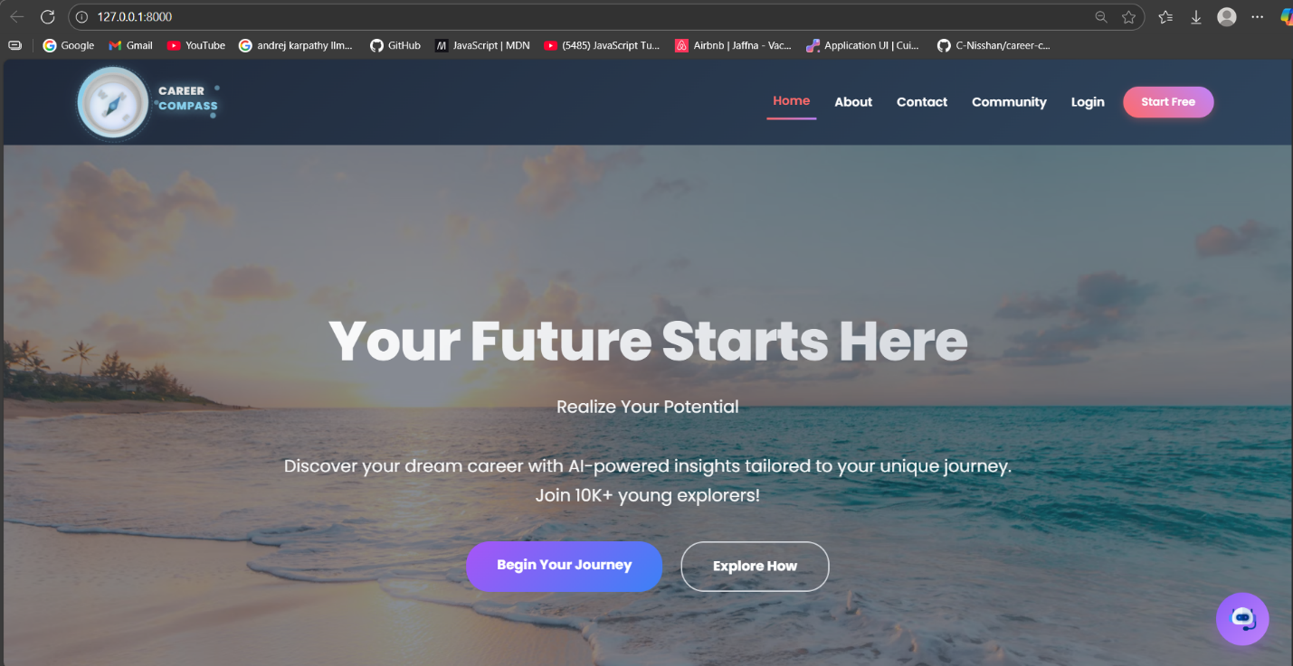

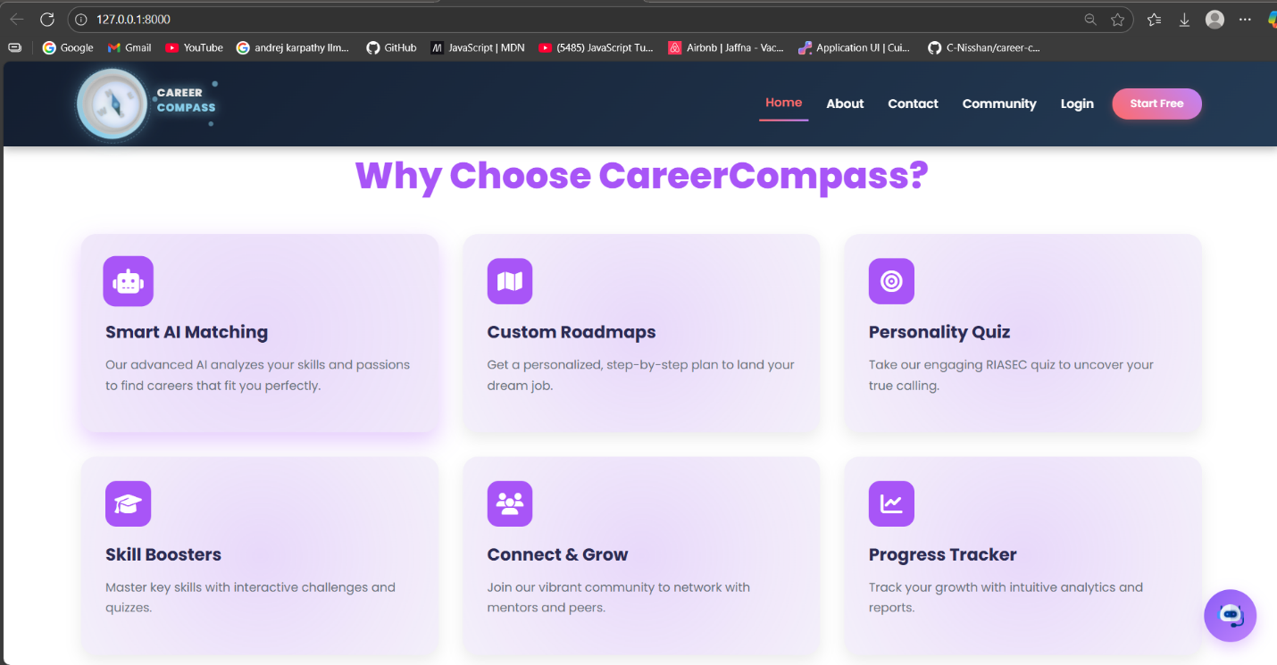

**About Page –** About page explaining the platform’s mission.

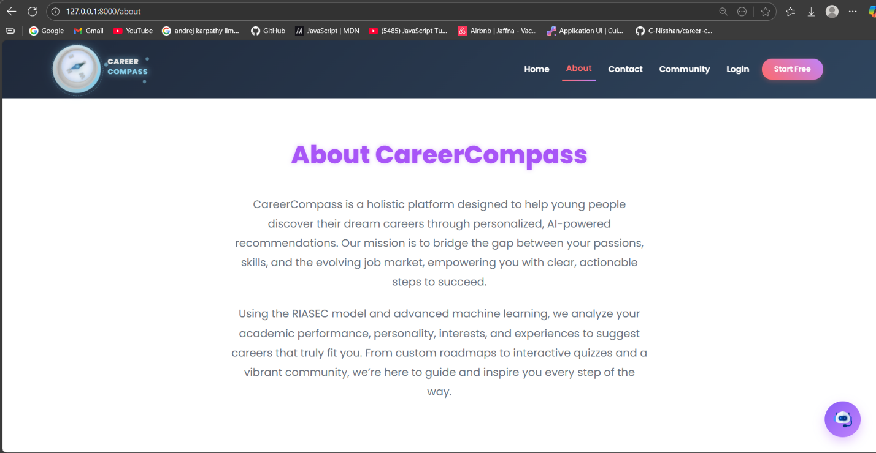

### 6.3.2 Authentication and User Management

* **What It Does**: Users (Students, Mentors, Admins) can log in, log out, register, and reset passwords. Guests can register as Students or Mentors.

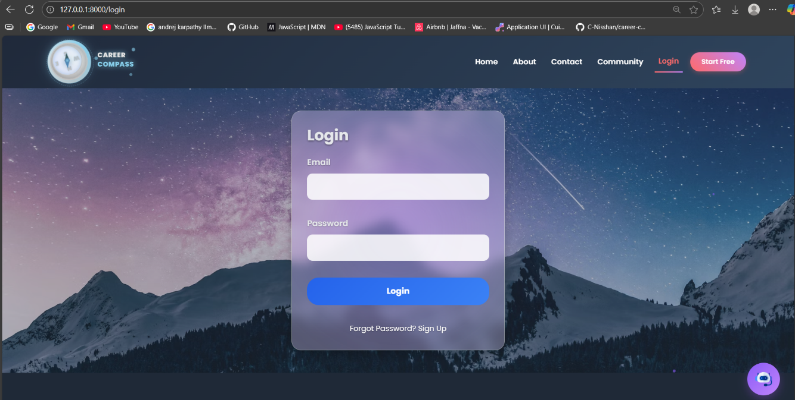

* **How We Built It**
  + **Login/Register**: Created Blade templates for login and registration forms, using Laravel’s authentication with JWT (JSON Web Tokens) for secure access.

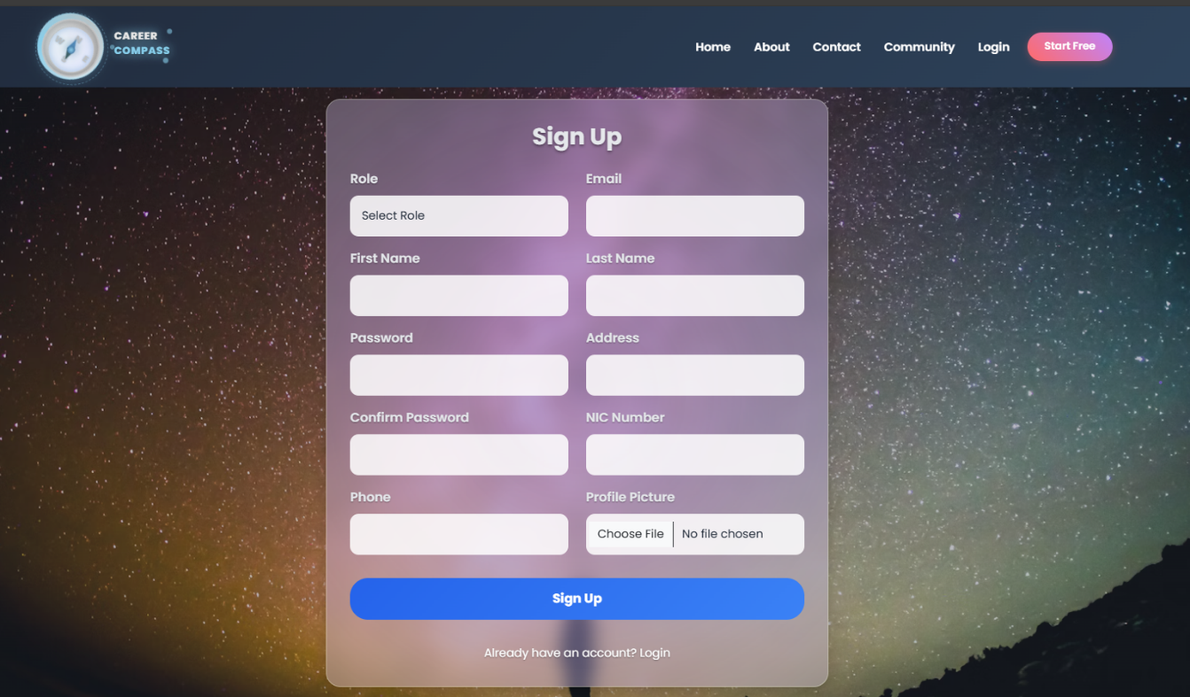

* + **Password Reset**: Built a password reset system using a one-time password (OTP) stored in the MySQL database. Emails with OTPs are sent via Google’s SMTP (smtp.gmail.com) to the user’s email.

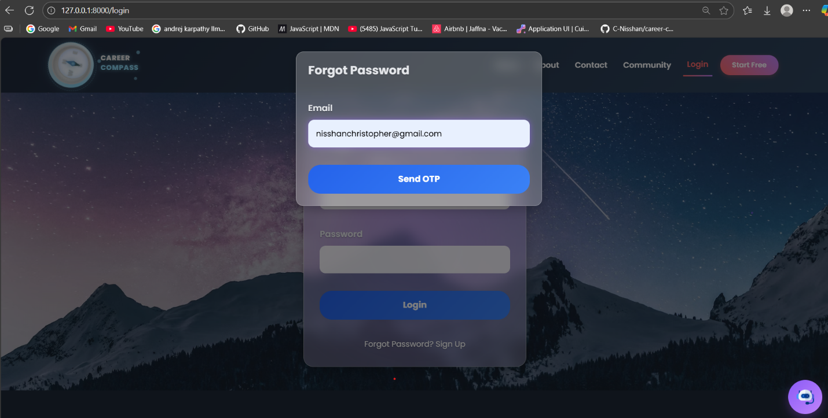

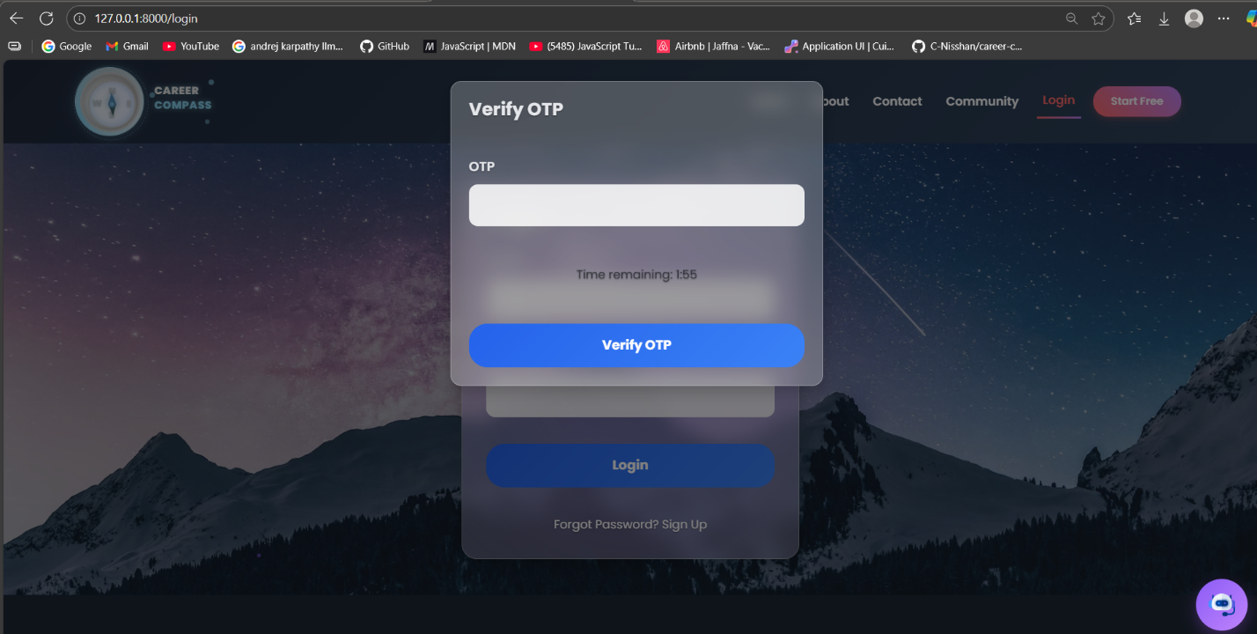

### 6.3.3 Contact Form

* **What It Does**: Guests and users can send inquiries via a contact form, which are saved in the database and confirmed by email.
* **How We Built It**: The contact.blade.php template creates a form styled with Bootstrap. The ContactController validates inputs (name, email, message) and saves them to the ContactMessage model. The ContactFormSubmitted mailable sends confirmation emails via Google’s SMTP (smtp.gmail.com). JavaScript handles form submission to the /api/contact/submit endpoint.

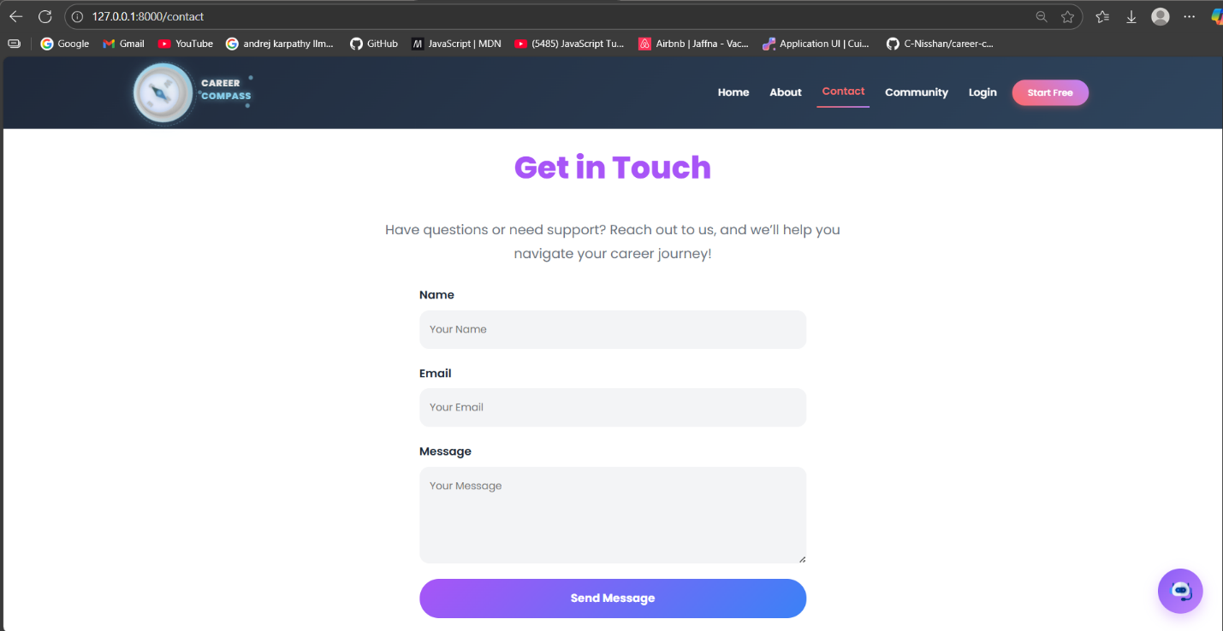

### 6.3.4 Career Recommendation Engine

* **What It Does**: Guests and Students get three career suggestions (e.g., software engineer, doctor) with explanations based on inputs like GPA, skills, and interests.
* **How We Built It**
  + **Frontend**: A chatbot-style interface (using JavaScript and Bootstrap) collects user inputs and sends them to Laravel via an API call.

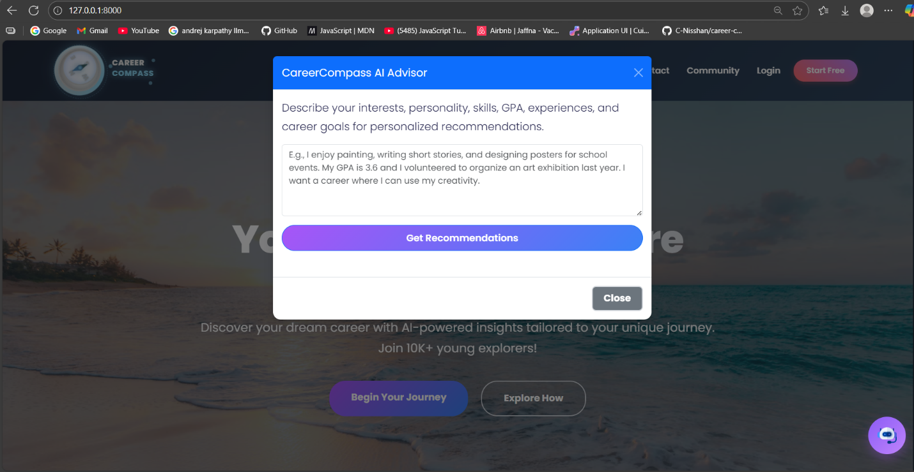

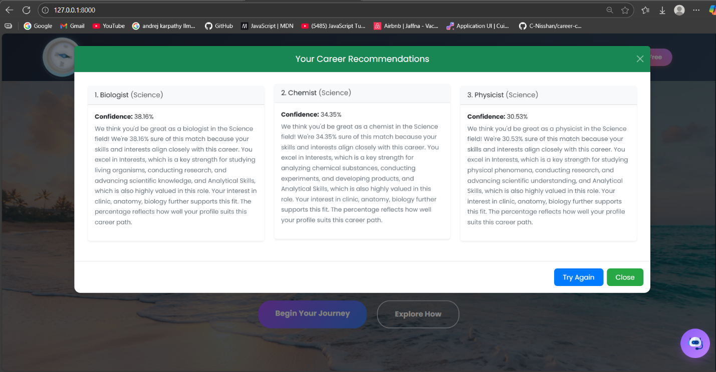

* + **Backend**: A Laravel controller processes inputs and sends a JSON request to the FastAPI /predict endpoint using Guzzle HTTP client. The FastAPI service, built with Python, uses a LightGBM model to predict a career field and select top-3 careers, returning results with confidence scores and explanations.
  + **ML Model**: Trained using Python (FastAPI, LightGBM 3.3, pandas 1.5, scikit-learn 1.2, NLTK 3.7) on Google Forms and Kaggle datasets. It extracts features (e.g., GPA, skills) using a scikit-learn pipeline and predicts careers.
  + **Output**: Laravel generates PDF reports of predictions using DomPDF 3.1 for Students to download.

### 6.3.5 Skill Quizzes

* **What It Does**: Students take quizzes to assess soft skills and technical skills with instant feedback and progress tracking.

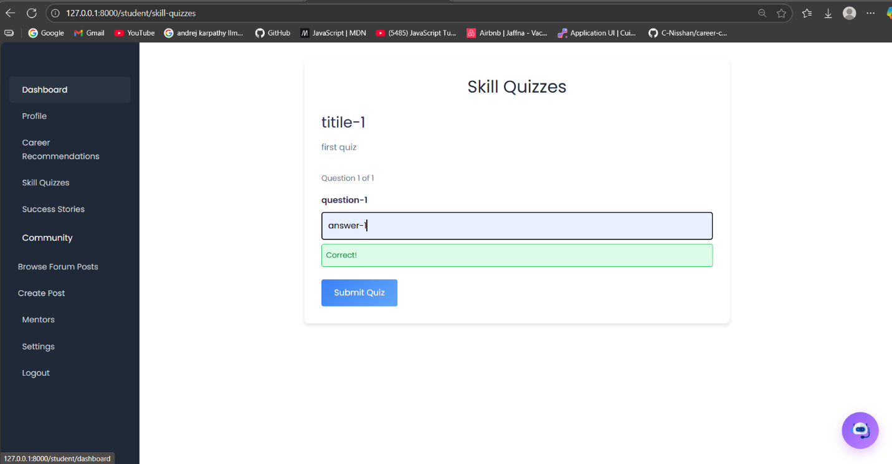

* **How We Built It**: Created Blade templates for quiz interfaces, with questions stored in the MySQL database. A controller processes submissions, calculates scores, and saves results for tracking. JavaScript displays feedback. The UuidTrait ensures unique quiz IDs.

### 6.3.6 Community Forum

* **What It Does**: Guests can view posts, while Students and Mentors can post, comment, and upvote. Admins moderate content.

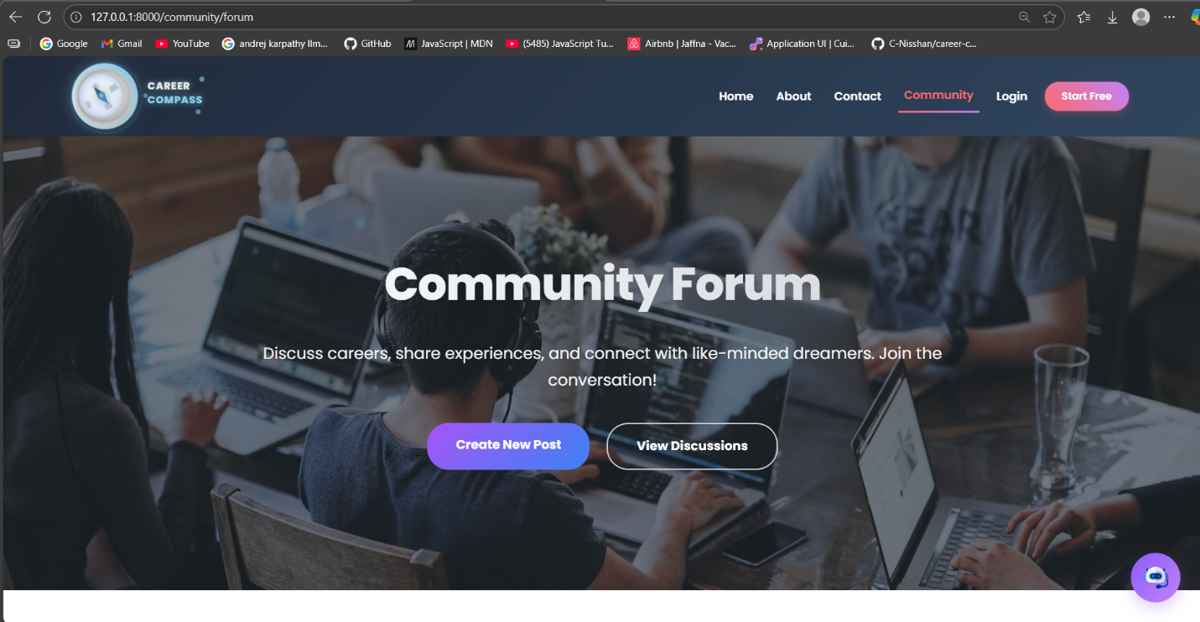

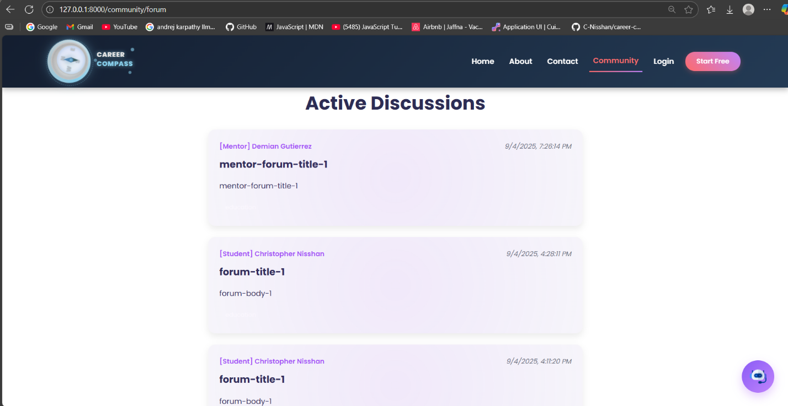

* **How We Built It**: Used Blade templates for the forum interface, styled with Bootstrap. The ForumVote model manages upvotes, linked to users via UUIDs. Controllers handle posting, commenting, and moderation. The CheckRoleMiddleware restricts actions to authenticated users.

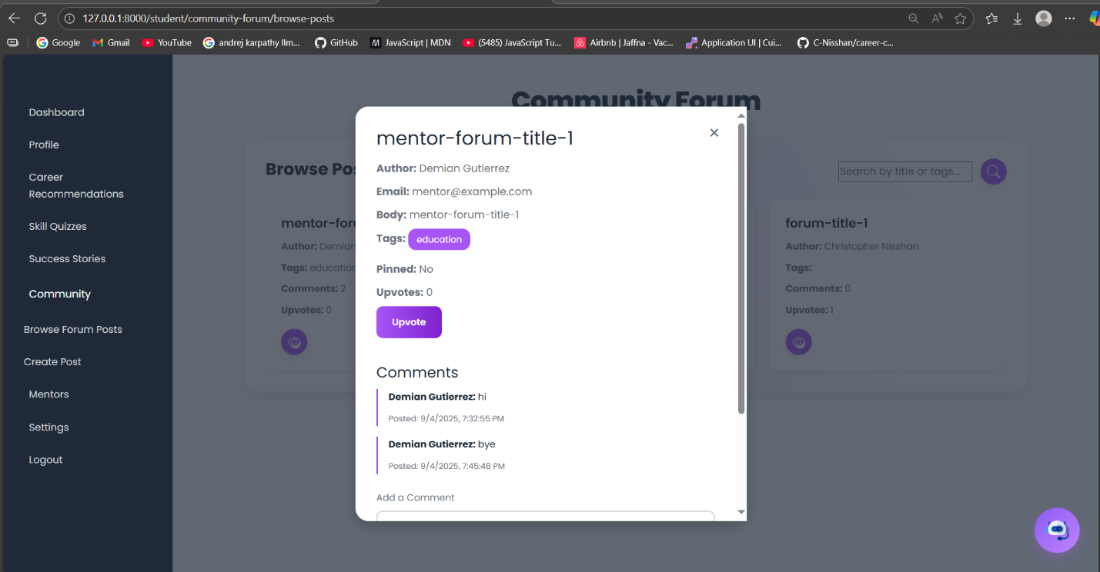

### 6.3.7 Student Features

* **What It Does**: Students have a dashboard showing career recommendations, quiz results, and forum activity. They can update profiles and view success stories.
* **How We Built It**
  + **Dashboard**: A Blade template displays dynamic data (recommendations, notifications) from the MySQL database, styled with Bootstrap.
  + **Profile Management**: A controller handles profile updates (e.g., skills, RIASEC traits) with validation and image uploads (JPEG/PNG, max 2MB).
  + **Success Stories**: Stored in the database and displayed via Blade templates, filterable by career field.

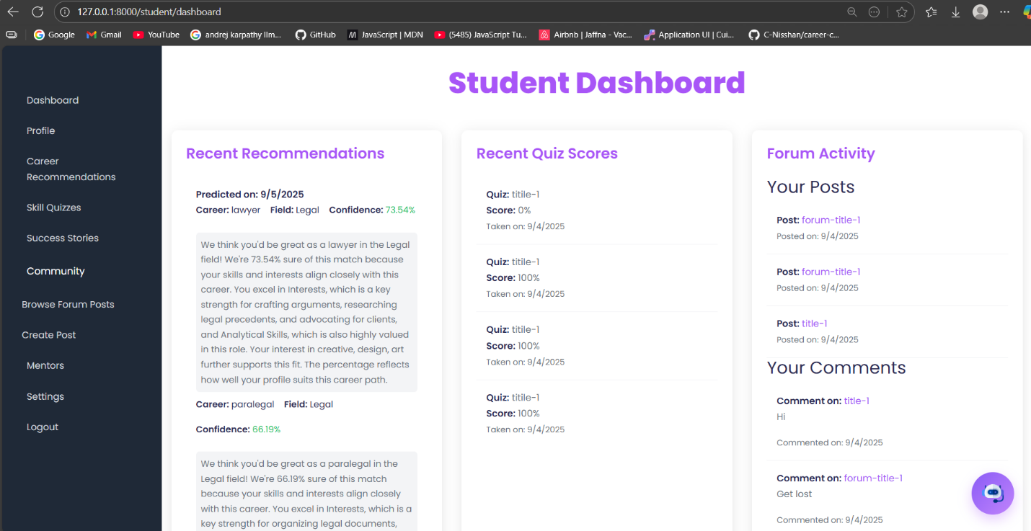

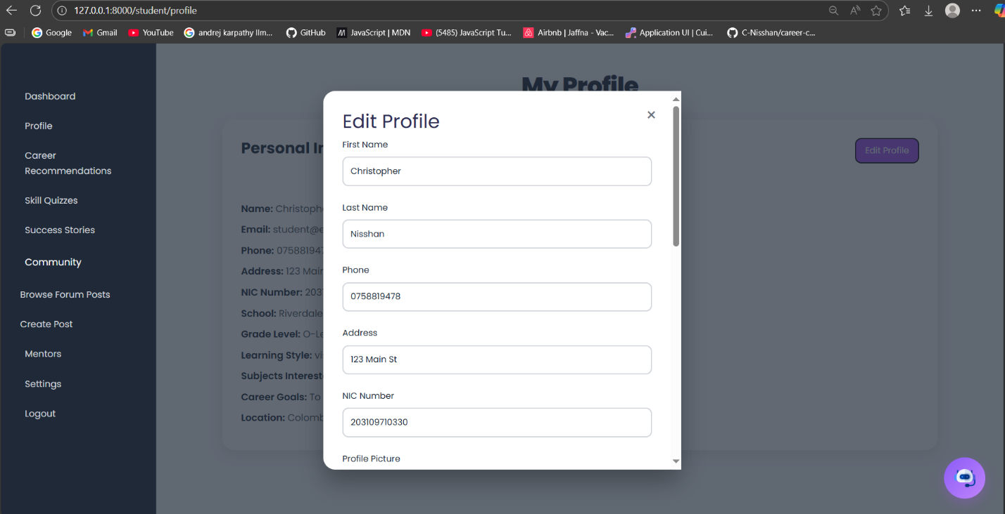

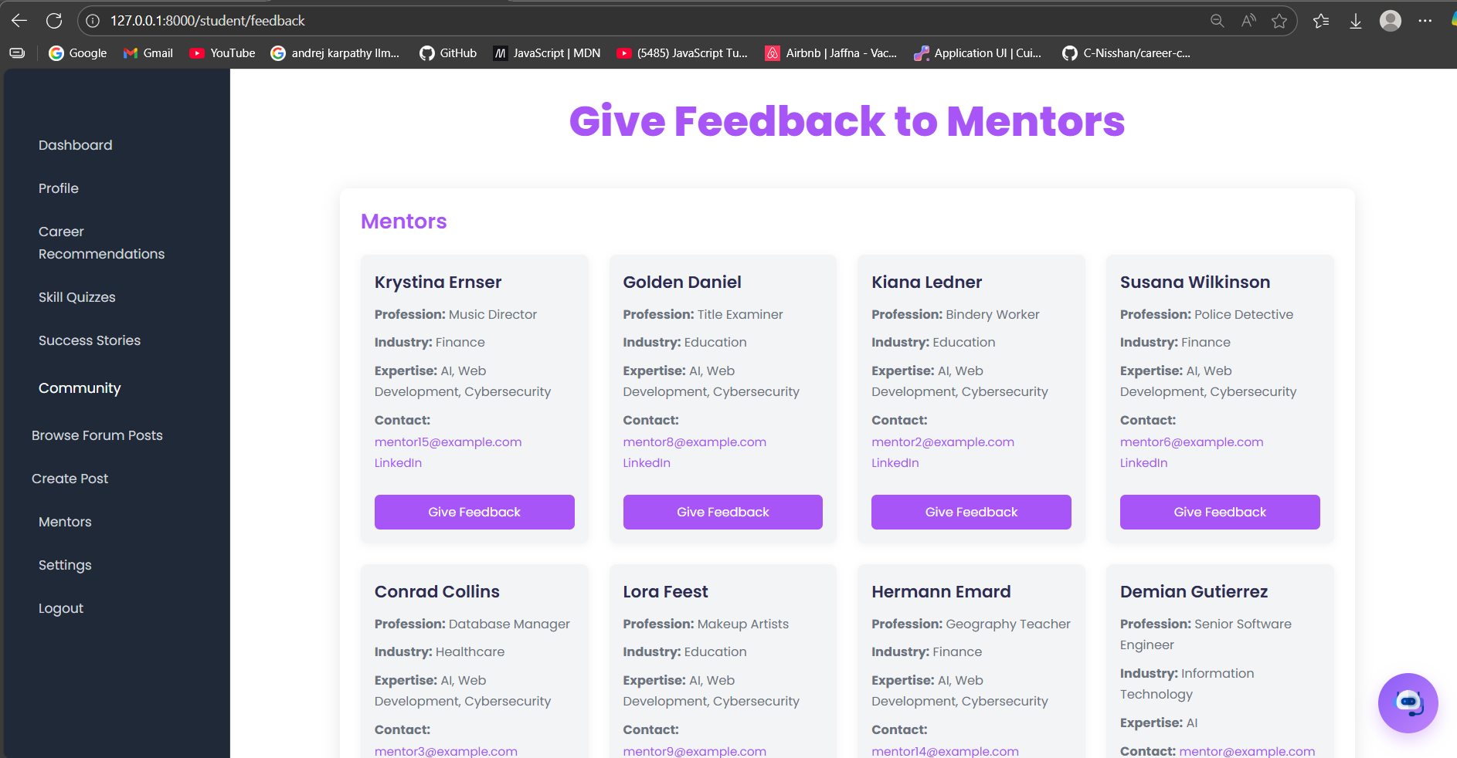

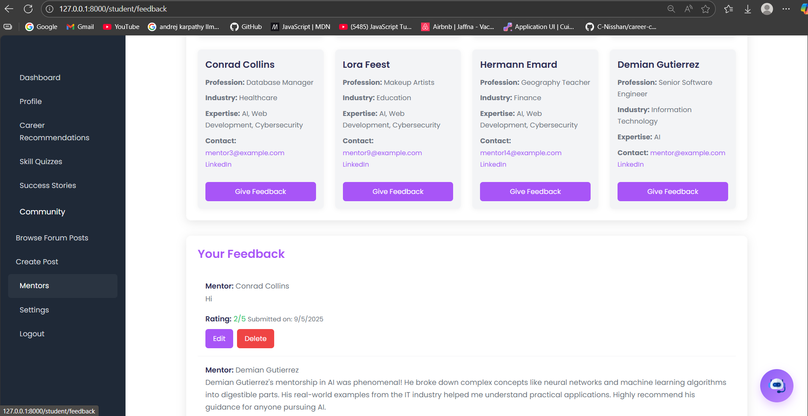

### 6.3.8 Mentor Features

* **What It Does**: Mentors have a dashboard with mentee interactions and forum activity, can update profiles, and view analytics.
* **How We Built It**: A Blade template shows mentor-specific data, styled with Bootstrap. Controllers manage profile updates and analytics (e.g., comments received). The CheckRoleMiddleware restricts access to mentors, with pending mentors limited to profile and settings pages.

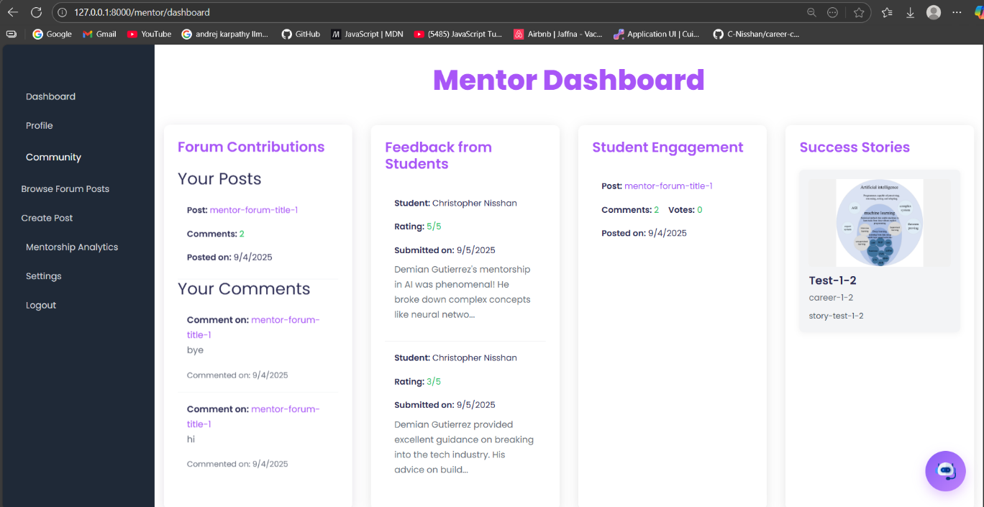

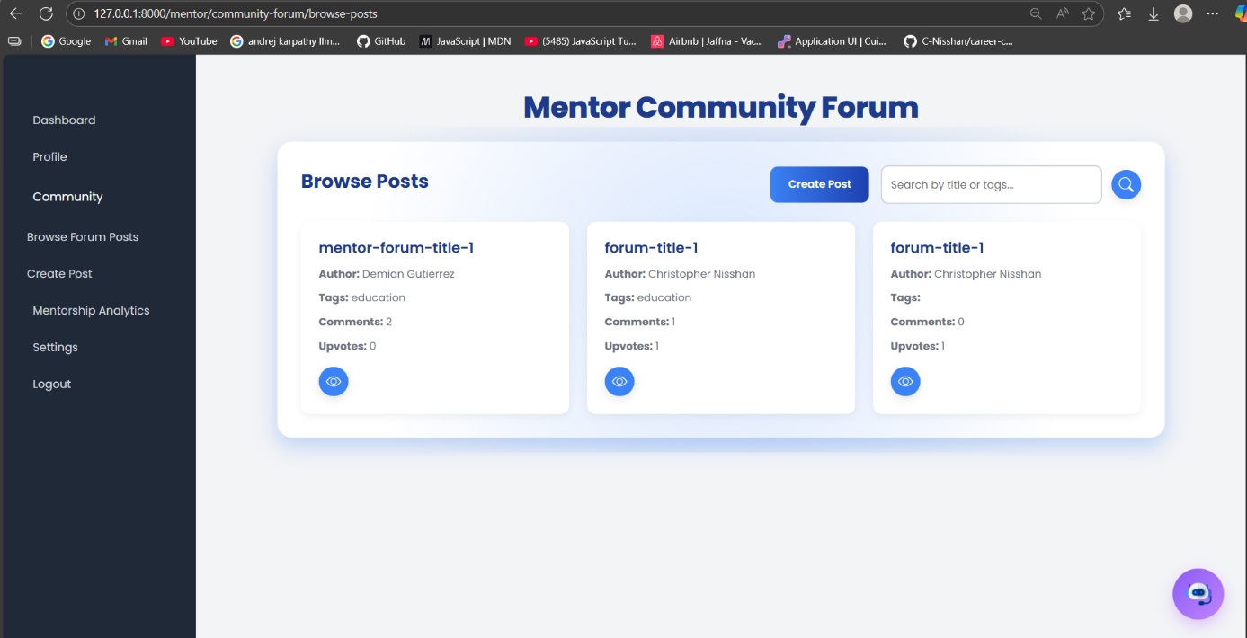

### 6.3.9 Admin Features

* **What It Does**: Admins manage users, approve mentors, moderate forums, manage quizzes and success stories, and view analytics.
* **How We Built It**
  + **Dashboard**: A Blade template displays statistics (e.g., user count, posts) from the MySQL database.

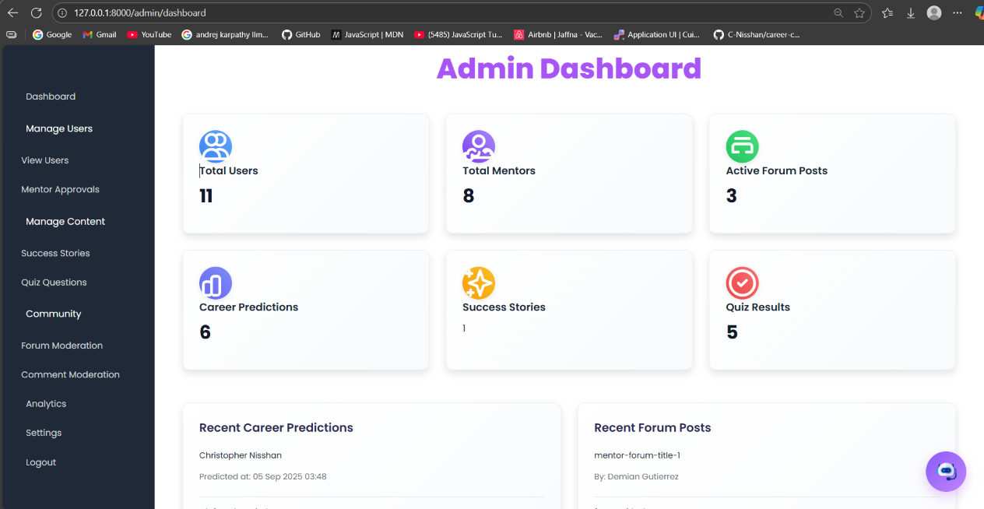

* + **User Management**: Controllers handle user activation/deactivation and mentor approvals, secured by CheckRoleMiddleware.

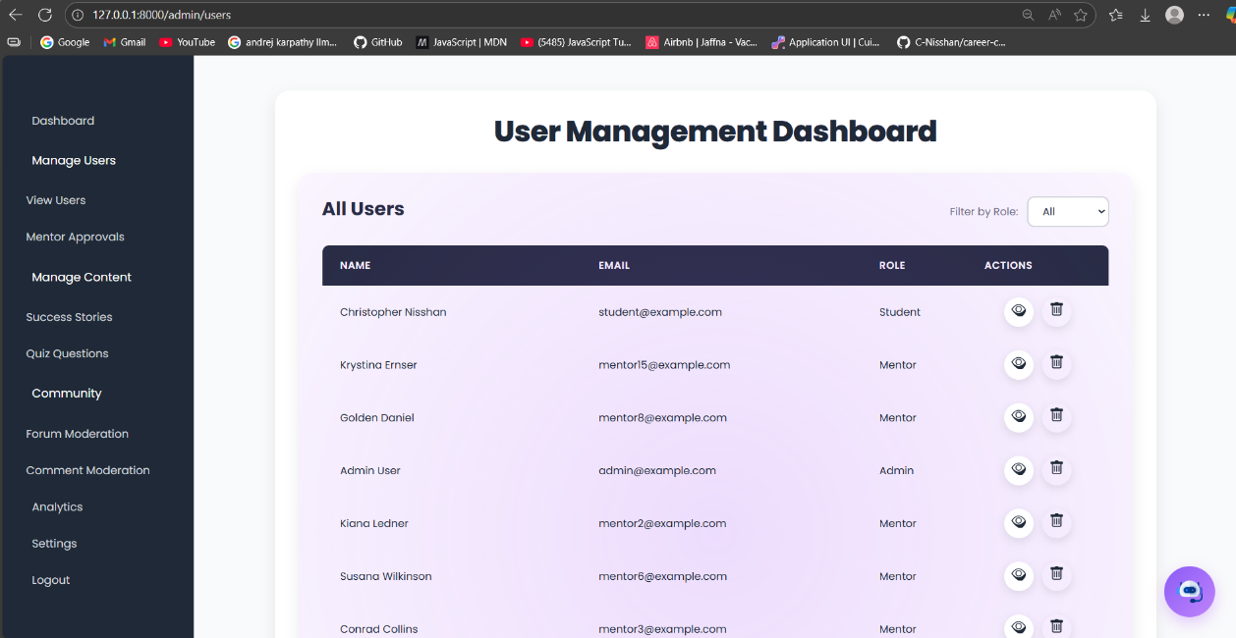

* + **Content Management**: CRUD operations for quizzes and success stories use controllers and Eloquent models.

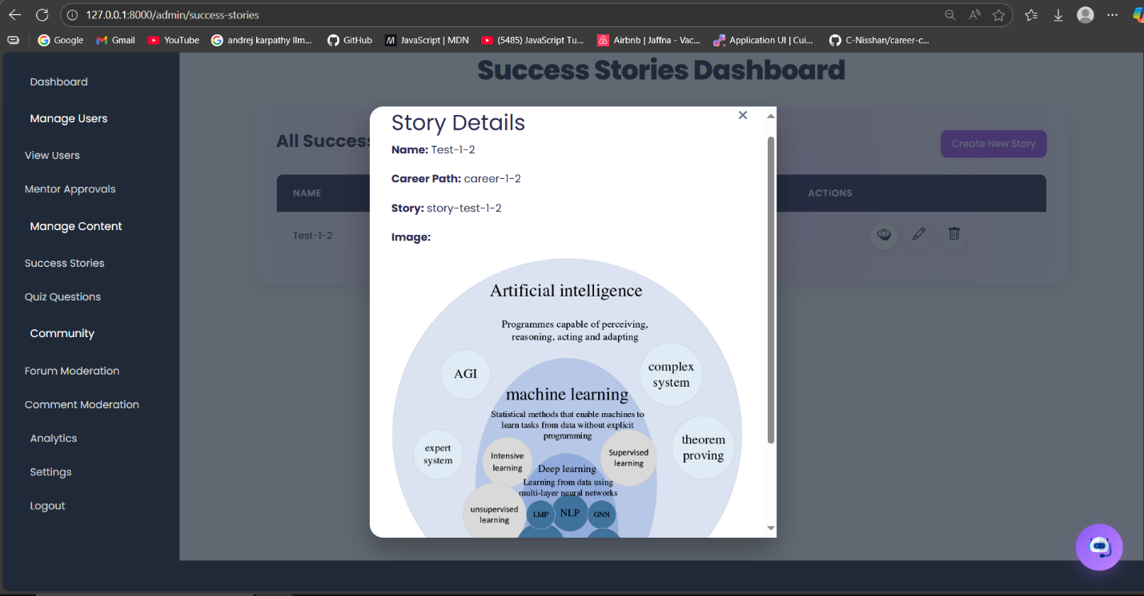

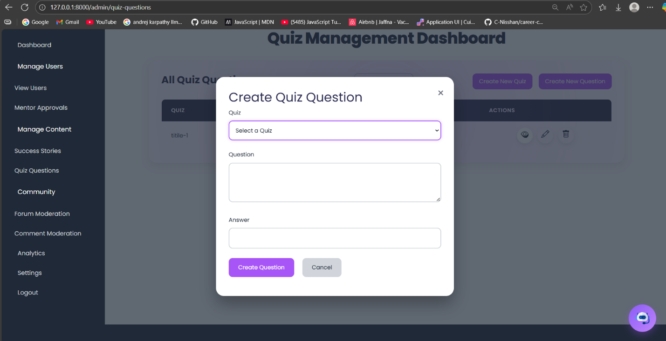

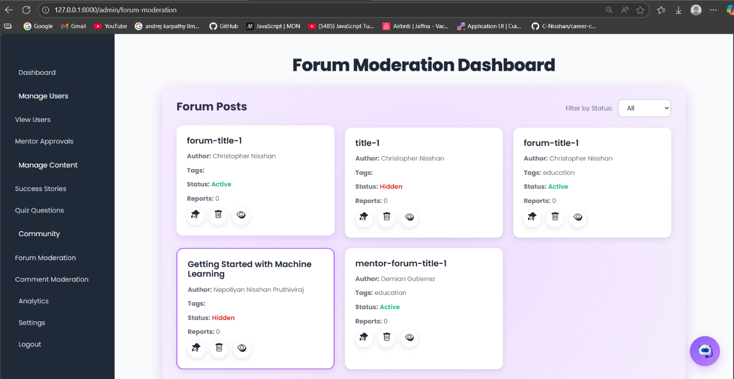

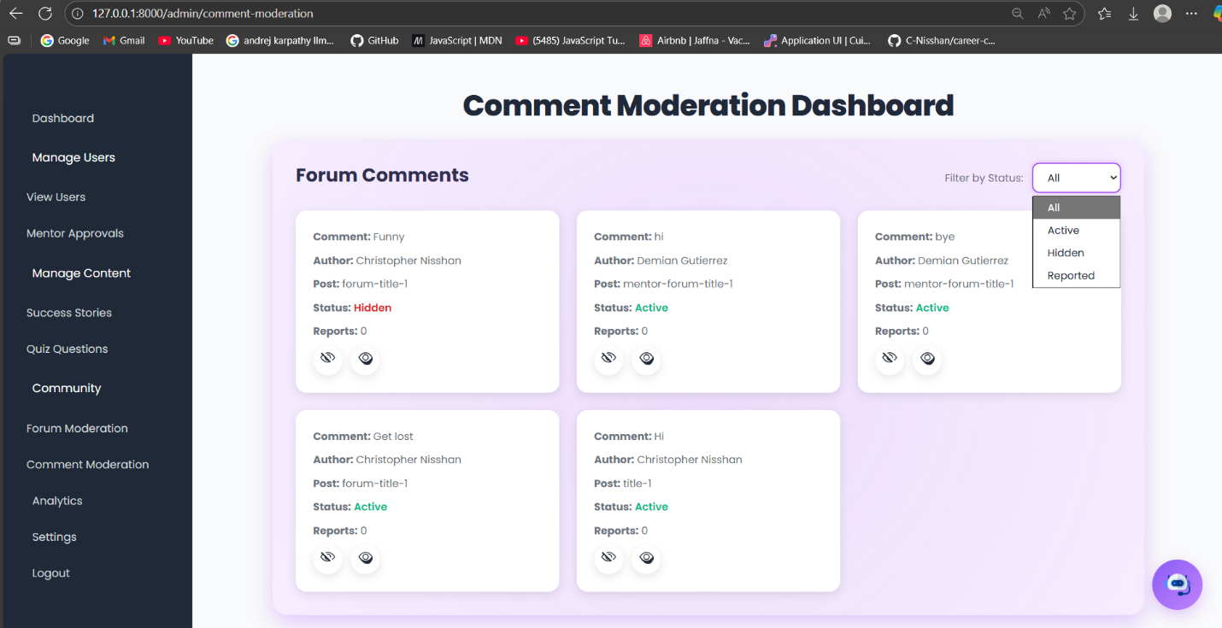

### 6.3.10 Development Process

* **Approach**: Developed solo using an iterative approach. Started with basic features (home, login, contact), then added complex ones (career recommendations, quizzes, forums), testing each part before moving forward.
* **Tools**: Used Visual Studio Code for coding, local server for running Laravel and MySQL, and Visual Studio Code for ML model development. Git tracked code changes.
* **Timeline**: Followed a three-month plan: Month 1 for setup and basic features, Month 2 for ML integration and role-specific features, Month 3 for testing and debugging.

### 6.3.11 Integration Details

* **Laravel and FastAPI**: Laravel sends user inputs (e.g., interests, GPA) as JSON to the FastAPI /predict endpoint using Guzzle. FastAPI processes inputs through the LightGBM model and returns three career suggestions with explanations. Laravel formats the response for display or PDF generation.
* **Data Flow**: Blade forms send inputs to Laravel controllers, which call the FastAPI API. The API returns JSON, which Laravel renders in views or stores in the MySQL database.
* **Authentication**: JWT tokens, managed by JwtFromCookieMiddleware, secure API calls, ensuring only authenticated users access features like PDF downloads.

### 6.3.12 Data Handling

* **Datasets**: Used Google Forms responses and Kaggle datasets (e.g., career_guidance_dataset.csv, Student_performance_data.csv) to train the LightGBM model.
* **Processing**
  + **Cleaning**: The ML script merged datasets, removed duplicates, and filled missing values with group medians. Text inputs were tokenized using NLTK for feature extraction.
  + **Feature Extraction**: Extracted features like GPA, Creative_Skills, and RIASEC traits, mapped to career fields (e.g., Technology, Healthcare) using top_words_dict and field_keywords.
  + **Training**: Used a scikit-learn pipeline for preprocessing (imputation, scaling) and feature selection (VarianceThreshold, SelectKBest). SMOTE balanced the dataset, and RandomizedSearchCV tuned the LightGBM model to achieve ≥80% accuracy.
* **Storage**: User inputs and quiz results are stored in MySQL tables, linked by UUIDs for consistency.

### 6.3.13 Challenges Faced

* **Dataset Issues**: Merging datasets was tough due to different formats and missing data. Custom code was needed to unify them and handle missing values.
* **ML Accuracy**: Getting ≥80% accuracy required multiple rounds of tuning the LightGBM model and selecting the right features.
* **API Integration**: Connecting Laravel to FastAPI had JSON formatting and HTTP errors, resolved using Postman for debugging.
* **Email Setup**: Configuring smtp.gmail.com was tricky due to Gmail’s security settings (e.g., app-specific passwords). Ensuring API keys were secure took extra effort.
* **Testing**: Manual testing of UI features (quizzes, forums) was time-consuming. PHPUnit helped with backend tests, but covering all cases was hard.

7.0 Testing and Validation 80

Test Plan 81

Test Cases 81

8.0 Conclusion 85

8.1 Conclusion 86

8.2 Future Recommendations 86

8.3 Lessons Learned 86

Gantt Chart 87

References 88

Appendix 1 90

Questionnaire and answers 90

Source codes

Test Case 95

Appendix 2

Supervision meeting log sheets

List of Figures

List of Tables

# References

Kulcsár, V., Dobrean, A. and Gati, I. (2020). Challenges and difficulties in career decision making: Their causes, and their effects on the process and the decision. *Journal of Vocational Behavior*, [online] 116(103346), p.103346. doi: <https://doi.org/10.1016/j.jvb.2019.103346>.

Hooley, T., Hertzberg, F., Mariager-Anderson, K., Saur, H., Åsa Sundelin, Janne Varjo, Vilhjálmsdóttir, G.T. and Soffía Valdimarsdóttir (2024). A systematic review of research into career guidance policy in the Nordic countries (2008-2022). *Nordic journal of studies in educational policy*, pp.1–14. doi: <https://doi.org/10.1080/20020317.2024.2352004>.

Wm.edu. (2025). *DSpace*. [online] Available at: <https://scholarworks.wm.edu/items/4fdc315c-b5d2-414d-a048-fb28dc64bb50>

My Next Move (2019). *My Next Move*. [online] Mynextmove.org. Available at: <https://www.mynextmove.org/>.

Hirschi, A. and Läge, D. (2008). Increasing the career choice readiness of young adolescents: an evaluation study. *International Journal for Educational and Vocational Guidance*, 8(2), pp.95–110. doi: <https://doi.org/10.1007/s10775-008-9139-7>.

Redekopp, D., Hopkins, S. and Hiebert, B. (2013). *ASSESSING THE IMPACT OF CAREER DEVELOPMENT RESOURCES AND PRACTITIONER SUPPORT ACROSS THE EMPLOYABILITY DIMENSIONS Canadian Career Development Foundation (CCDF) in partnership with Fondation canadienne pour le développement de carrière Canadian Career Development Foundation*. [online] Available at: <https://ccdf.ca/wp-content/uploads/2022/06/Employability-Dimensions-Report-2013-5-30-FINAL-CCDF.pdf>.

UNESCO (2024). *What you need to know about digital learning and transformation of education*. [online] Unesco.org. Available at: <https://www.unesco.org/en/digital-education/need-know?hub=84636>.

Geethanjana, H.K., Sirisuriya, M. and Abesinghe, D.V.D.S. (2025). NextStep: A Smart System-Based Career Guidance Application for Students in the Computing Field Based on the RIASEC Model. *2025 International Research Conference on Smart Computing and Systems Engineering (SCSE)*, [online] pp.1–6. doi: <https://doi.org/10.1109/scse65633.2025.11031008>.

Nguyen, H.Q., Nguyen, D.D.K., Le, T.D., Mai, A. and Huynh, K.T. (2023). Career path prediction using XGBoost Model and students’ academic results. *CTU Journal of Innovation and Sustainable Development*, [online] 15(ISDS), pp.62–75. doi: <https://doi.org/10.22144/ctujoisd.2023.036>.

Biau, G. and Scornet, E. (2015). A Random Forest Guided Tour. *arXiv:1511.05741 [math, stat]*. [online] Available at: <https://arxiv.org/abs/1511.05741>.

Hoff, K.A., Song, Q.C., Wee, C.J.M., Phan, W.M.J. and Rounds, J. (2020). Interest fit and job satisfaction: A systematic review and meta-analysis. *Journal of Vocational Behavior*, [online] 123, p.103503. doi: <https://doi.org/10.1016/j.jvb.2020.103503>.

Silva, A., Lo, P.-C. and Lim, E.-P. (2020). JPLink: On Linking Jobs to Vocational Interest Types. *Lecture notes in computer science*, pp.220–232. doi: <https://doi.org/10.1007/978-3-030-47436-2_17>.

Rahman, Muh.F., Alamsyah, Muh.N. and Firdaus, H. (2025). Implementation of the RIASEC Model Career Guidance Guide through Career Information Services for Junior High School Students. *Bulletin of Social Studies and Community Development*, 3(1), pp.55–64. doi: <https://doi.org/10.61436/bsscd/v3i1.pp55-64>.

Gladstone, J.R. and Cimpian, A. (2021). Which Role Models Are Effective for Which students? a Systematic Review and Four Recommendations for Maximizing the Effectiveness of Role Models in STEM. *International Journal of STEM Education*, 8(1). Doi: <HTTPs://doi.org/10.1186/s40594-021-00315-x>.

Ronnie, S., Santos, I., Santos, R. and Magalhaes, C. (2024). *Diversity in Software Engineering Education: Exploring Motivations, Influences, and Role Models Among Undergraduate Students*. [online] arXiv.org. Available at: <https://arxiv.org/abs/2412.12378>

Warrner, J. (n.d.). *Creating Connections: The Importance and Impact of Mentoring Students*. [online] Available at: <https://files.eric.ed.gov/fulltext/ED649357.pdf>.

Miske, S. and Sogunro, O. (2024). Effects of a Mentorship Program on High Need College Students: Reflections from Mentors and Mentees. *Journal of Educational Research and Practice*, [online] 14(1). doi: <https://doi.org/10.5590/JERAP.2024.14.1.06>.

‌ Nabi, G., Walmsley, A., Mir, M. and Osman, S. (2024). The Impact of Mentoring in Higher Education on Student Career development: a Systematic Review and Research Agenda. *Studies in Higher Education*, 50(4), pp.1–17. doi: <https://doi.org/10.1080/03075079.2024.2354894>.

Graham, M., Wayne, I., Persutte-Manning, S., Pergantis, S. and Vaughan, A. (2022). Enhancing Student Outcomes: Peer Mentors and Student Transition. *International Journal of Teaching and Learning in Higher Education 2022*, [online] 34(1), pp.1–6. Available at: <https://files.eric.ed.gov/fulltext/EJ1363722.pdf>.

Ijnrd.org. (2016). *IJNRD - UGC CARE Journal Norms and Guidelines follow - International Journal of Novel Research and Development*. [online] Available at: <https://ijnrd.org/>.

‌

‌

‌

‌

‌

‌

‌